INTERNSHIP REPORT 2024

Submitted To

SAI SATISH

Artificial Intelligence Medical and Engineering Researchers Society

info@AimersSociety.com

Submitted By

GURRAM TEJASRI

22551A0592 GODAVARI INSTITUTE OF ENGINEERING & TECHNOLOGY

# About AIMERS:

**Details about AIMER Society**

Name: Artificial Intelligence Medical and Engineering Researchers Society (AIMER Society)

# Overview:

The Artificial Intelligence Medical and Engineering Researchers Society (AIMER Society) stands as a premier professional organization at the forefront of the advancement of Artificial Intelligence (AI) within the realms of medical and engineering research. This esteemed society is committed to driving innovation and excellence in AI by fostering a collaborative environment among researchers, practitioners, and students from diverse backgrounds and disciplines.

The AIMER Society's mission is to serve as a catalyst for the development and application of cutting-edge AI technologies that can address complex challenges in healthcare and engineering. By creating a vibrant and inclusive platform, the society facilitates the exchange of knowledge, ideas, and best practices among its members. This collaborative approach ensures that AI research is not only innovative but also practically applicable, leading to real- world solutions that can significantly improve medical outcomes and engineering processes.

In pursuit of its mission, the AIMER Society organizes a wide array of activities and initiatives designed to promote AI research and development. These include annual conferences, symposiums, and workshops that bring together leading AI experts to discuss the latest advancements and trends.

# Mission:

The mission of the AIMER Society is to promote the development and application of AI technologies to solve complex medical and engineering problems, improve healthcare

outcomes, and enhance engineering solutions. The society aims to bridge

the gap between theoretical research and practical implementation, encouraging interdisciplinary collaboration and real-world impact.

# Objectives:

1. To advance research in AI and its applications in medical and engineering fields.
2. To provide a platform for researchers, practitioners, and students to share knowledge and collaborate on AI projects.
3. To organize conferences, workshops, and seminars for the dissemination of AI research and knowledge.
4. To support the professional development of AI researchers and practitioners through training programs, certifications, and networking opportunities.
5. To foster ethical AI practices and address societal challenges related to AI deployment.

# Key Activities:

1. Conferences and Workshops: Organizing annual conferences, symposiums, and workshops that bring together leading AI experts, researchers, and practitioners to discuss the latest advancements and trends in AI.
2. Research Publications: Publishing high-quality research papers, journals, and articles on AI technologies and their applications in medical and engineering fields.
3. Competitions and Contests: Hosting AI model development and chatbot contests to encourage innovation and practical applications of AI among students and professionals.
4. Training Programs: Offering training and certification programs in AI and related technologies to enhance the skills and knowledge of members.
5. Collaboration Projects: Facilitating collaborative projects between academia, industry, and healthcare institutions to drive AI innovation and practical solutions.

# Membership:

The AIMER Society offers various membership categories, including individual, student, and corporate memberships. Members gain access to exclusive resources, networking opportunities, and discounts on events and publications. The society encourages participation from AI enthusiasts, researchers, practitioners, and organizations interested in the advancement of AI technologies.

# Leadership:

The AIMER Society is led by a team of experienced professionals and experts in the fields of AI, medical research, and engineering. The leadership team is responsible for strategic planning, organizing events, and guiding the society towards achieving its mission and objectives.

# Impact and Achievements:

1. Developed AI models for early diagnosis and treatment of medical conditions.
2. Contributed to significant advancements in engineering solutions through AI technologies.
3. Fostered a global community of AI researchers and practitioners.
4. Organized successful conferences and workshops with high participation and impactful outcomes.
5. Published influential research papers and articles in reputed journals.

# Future Goals:

1. Expand the scope of research and applications in AI to cover emerging fields and technologies.
2. Increase collaboration with international AI societies and organizations.
3. Enhance training and certification programs to meet the evolving needs of AI professionals.
4. Promote ethical AI practices and address challenges related to AI governance and societal impact.

# Contact Information:

* Website: AIMER Society Website [http://www.aimersociety.com](http://www.aimersociety.com/)
* Email: info@aimersociety.orginfo@aimersociety.org

- Phone: +91 9618222220

* Address: Sriram ChandraNagar, Vijayawada

# List of Topics in AI:

|  |  |
| --- | --- |
| **Si.No.** | **Topics** |
| 1 | Computer Vision |
| 2 | Convolutional Neural Networks (CNN) |
| 3 | Image Classification |
| 4 | Image Object Detection |
| 5 | YOLO (You Only Look Once) |
| 6 | Medical Image Analysis and Labelling |
| 7 | Human Pose Estimation: Google teachable machine |
| 8 | Mediapipe Studio: Hand gestures screenshots |
| 9 | OpenCV Basics |
| 10 | Chatbot Development |
| 11 | Google Dialogflow |
| 12 | Generative AI |
| 13 | AI Models |
| 14 | Visual Question & Answering |
| 15 | Document Question & Answering |
| 16 | Table Question & Answering |
| 17 | Large Language Models |
| 18 | Other Topics |

**Tasks Performed:**

|  |  |  |
| --- | --- | --- |
| **Si.No.** | **Task** | **Hyperlink of Project** |
| 1 | Image Classification | <https://www.linkedin.com/posts/gurram-teja-sri-425b5930b_computervision-machinelearning-teachablemachine-activity-7213787452421922817-YYiR?utm_source=share&utm_medium=member_desktop> |
| 2 | Object Detection | <https://www.linkedin.com/posts/gurram-teja-sri-425b5930b_artificialintelligence-objectdetection-yolo-activity-7210149363585634304-GzpG?utm_source=share&utm_medium=member_desktop> |
| 3 | Chatbot | <https://www.linkedin.com/posts/gurram-teja-sri-425b5930b_aicompetition-chatbotchallenge-aimers-activity-7212785348689424384-4UPr?utm_source=share&utm_medium=member_desktop> |
| 4 | Visual Question Answer Model | <https://www.linkedin.com/posts/gurram-teja-sri-425b5930b_ai-machinelearning-visualquestionanswering-activity-7210158417208922112-eOLC?utm_source=share&utm_medium=member_desktop> |

|  |  |  |
| --- | --- | --- |
| 5 | Power BI Report | <https://www.linkedin.com/posts/gurram-teja-sri-425b5930b_aimers-aimersociety-apsche-activity-7209210073233948672-um2Q?utm_source=share&utm_medium=member_desktop> |
| 6 | Summarization | <https://www.linkedin.com/posts/gurram-teja-sri-425b5930b_ai-naturallanguageprocessing-techinnovation-activity-7213590906522787841-J8xF?utm_source=share&utm_medium=member_desktop> |
| 7 | Generative AI comics | <https://www.linkedin.com/posts/gurram-teja-sri-425b5930b_ai-machinelearning-deeplearning-activity-7213785816026759168-glX4?utm_source=share&utm_medium=member_desktop> |

# Executive Summary:

This report provides an overview of my internship experience at AIMERS, focusing on the projects and tasks I undertook within the field of Artificial Intelligence (AI). Over the course of my internship, I engaged in several key projects that contributed to my understanding and application of AI techniques and tools, as well as the overall objectives of the organization.

# Projects:

1. Image Classification:
   * Objective: Develop a machine learning model for image classification to identify and categorize different objects or patterns in images.
   * Project Description: For Image classification I used google teachable machine. Google Teachable Machine is an easy-to-use platform that allows users to train machine learning models without deep technical knowledge.
   * Project-link: <https://www.linkedin.com/posts/gurram-teja-sri-425b5930b_computervision-machinelearning-teachablemachine-activity-7213787452421922817-YYiR?utm_source=share&utm_medium=member_desktop>
2. Object Detection:
   * Objective: The primary objective of the Object Detection Project is to develop a robust and accurate machine learning model capable of identifying and localizing objects within images and video streams.
   * Project Description: This project involves developing an advanced object detection model using Roboflow, a powerful platform for managing, preprocessing, and augmenting computer vision datasets.
   * Project-link: <https://www.linkedin.com/posts/gurram-teja-sri-425b5930b_artificialintelligence-objectdetection-yolo-activity-7210149363585634304-GzpG?utm_source=share&utm_medium=member_desktop>
3. Chat Bot:
   * Objective: The primary objective of the Bot using the OpenAI API is to create a sophisticated and interactive Chatbot capable of engaging with users on the chatbot platform.
   * Project Description: This project aims to develop an intelligent bot using the OpenAI API, capable of engaging users in natural and meaningful conversations.
   * Project-link: <https://www.linkedin.com/posts/gurram-teja-sri-425b5930b_aicompetition-chatbotchallenge-aimers-activity-7212785348689424384-4UPr?utm_source=share&utm_medium=member_desktop>
4. Visual Question Answer Model:
   * Objective: The primary objective of the Visual Question Answer (VQA) project using Hugging Face is to develop a robust and accurate system that can understand and respond to questions about images.
   * Project Description: The Visual Question Answer (VQA) project using Hugging Face aims to develop an intelligent system capable of

answering questions about images using advanced natural language processing (NLP) and computer vision techniques.

* + Project-link: <https://www.linkedin.com/posts/gurram-teja-sri-425b5930b_ai-machinelearning-visualquestionanswering-activity-7210158417208922112-eOLC?utm_source=share&utm_medium=member_desktop>

1. Power BI Report:
   * Objective: The primary objective of the Power BI report on literacy rates is to visually analyze and present comprehensive insights into global or regional literacy trends.
   * Project Description: The Power BI report on literacy rates aims to provide a comprehensive and visually insightful analysis of global

literacy trends using interactive data visualizations.

* + Project-link: <https://www.linkedin.com/posts/gurram-teja-sri-425b5930b_aimers-aimersociety-apsche-activity-7209210073233948672-um2Q?utm_source=share&utm_medium=member_desktop>

1. Summarization:
   * Objective: The primary objective of the Summarization project using Hugging Face is to develop an advanced natural language processing (NLP) system capable of generating concise and informative summaries from large volumes of text.
   * Project Description: The Summarization project using Hugging Face aims to develop a powerful and scalable natural language processing (NLP) system capable of automatically generating concise and coherent summaries from large volumes of text.
   * Project-link: <https://www.linkedin.com/posts/gurram-teja-sri-425b5930b_ai-naturallanguageprocessing-techinnovation-activity-7213590906522787841-J8xF?utm_source=share&utm_medium=member_desktop>
2. Generative AI comics:
   * Objective: The objective of the Generative AI Comics project is to develop an innovative AI-powered system capable of autonomously generating comic strips or panels that entertain, engage, and potentially educate audiences.
   * Project Description: The Generative AI Comics project aims to revolutionize comic creation by leveraging advanced artificial intelligence techniques to autonomously generate engaging and visually

appealing comic strips or panels.

* + Project-link: <https://www.linkedin.com/posts/gurram-teja-sri-425b5930b_ai-machinelearning-deeplearning-activity-7213785816026759168-glX4?utm_source=share&utm_medium=member_desktop>

# Skills Learnt:

1. **Computer Vision**
   * Computer Vision is a field of AI.
   * Computer Vision is an interdisciplinary scientific field that deals with how computerscan gain high-level understanding from digital images or videos. From the perspectiveof engineering, it seeks to understand and automate tasks that the human visual system can do.
   * Typically, this involves developing methods that attempt to reproduce the capabilityof human vision.
   * The ultimate goal of computer vision is to initiate the great capabilities of human visual system. Computer vision allows the computers not only to record images butalso to interpret them.

*The Power of Computer Vision in AI: Unlocking the Future!*

#### Applications of Computer Vision:

* + Facial recognition
  + Self-driving cars
  + Robotic automation
  + Sports performance analysi

# Convolutional Neural Networks(CNN):

* + A CNN is a type of artificial neural network used primarily for imagerecognition and processing.
  + A class of deep neural networks, most commonly applied to analyzing visualimagery.
  + CNN are also known as shift invariant or space invariant artificial neuralnetworks (SIANN).

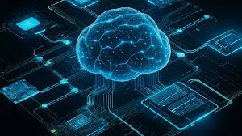

*Convolutional Neural Network*

# Applications of CNN:

* + Image recognition
  + Analyzing documents
  + Medical imaging
  + Autonomous driving
  + Segmentation
  + Decoding facial recognition
  + Collecting Historic and Environmental elements
  + Understanding climate

# Image classification:

**Google Teachable Machine:** The process of categorizing and labelling groupsof pixels or vectors within an image based on specific rules.

#### Let’s Build a Model:

Step 1: Go to Google Teachable Machine. You should be directed to the below shown picturethat consists of three options Image, Audio, Pose.

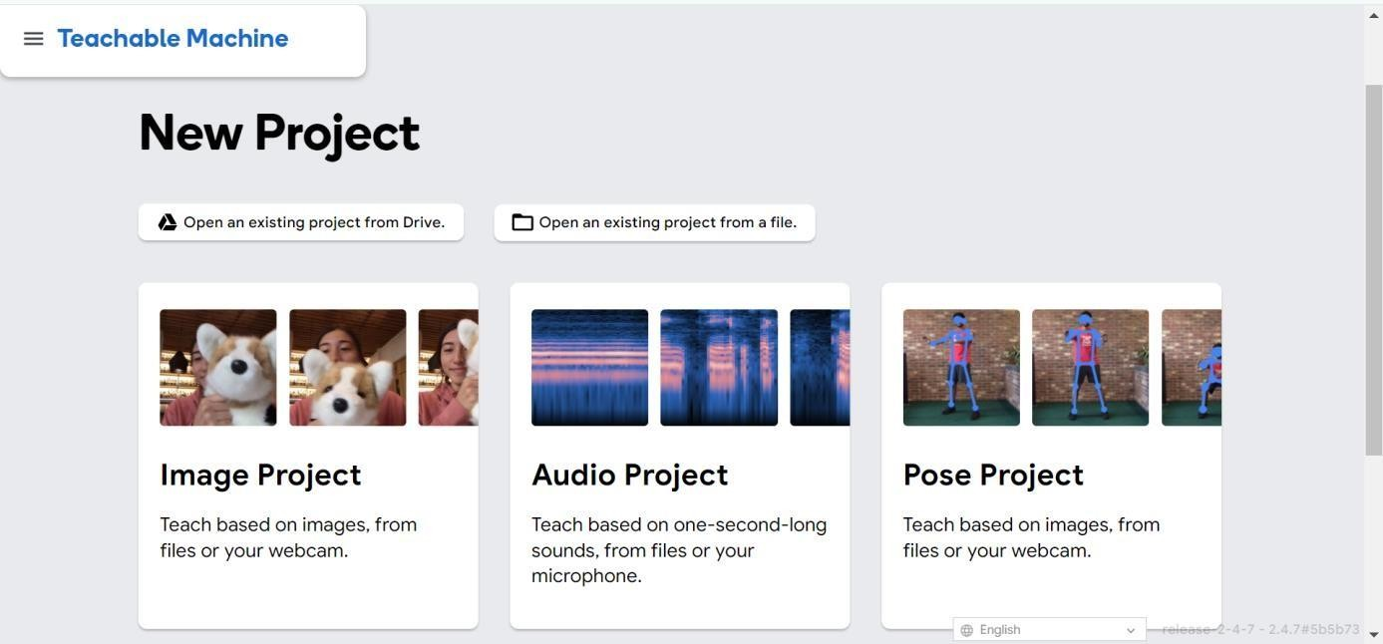

Step 2: Choose the Image project. You will see two options, Standard and Embedded. ChooseStandard Image Model because we are not making it for the purpose of microcontrollers. If you choose Embedded Image Model the process will be same as Standard Image Model but the model will be different.

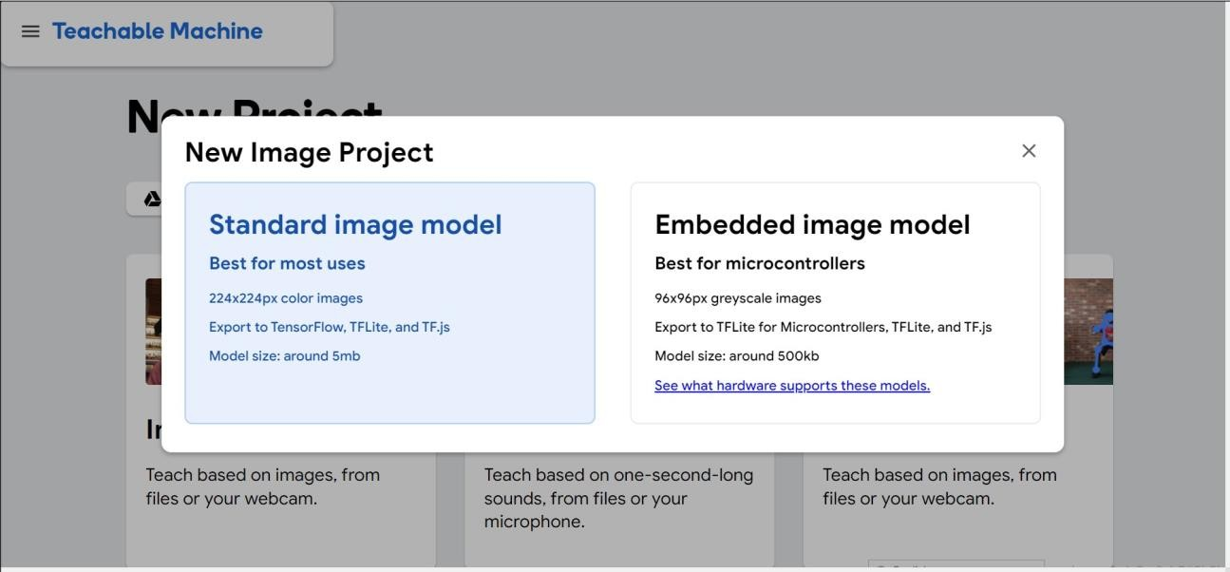

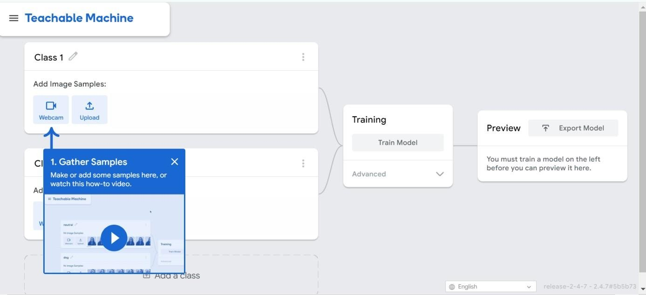After clicking on Standard Image Project, you will be directed to the below picture, where weadd classes. There are two options-either you upload images or use the live camera to capturethe images.

Step 3: Now, create classes and start uploading the images. Replace class1 with Mobile,class2 with Book, class3 with Pen. After uploading the images click on Train Model.

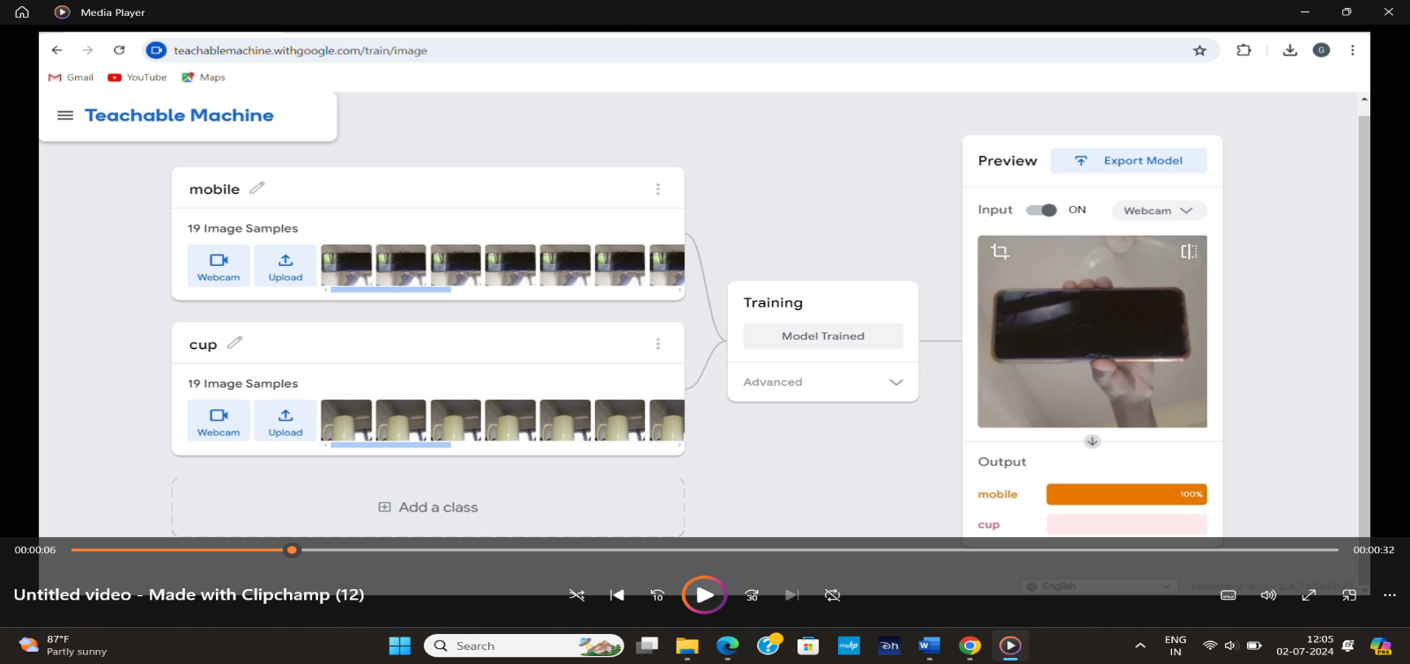

Step 4: After the model is trained, its time to export the model

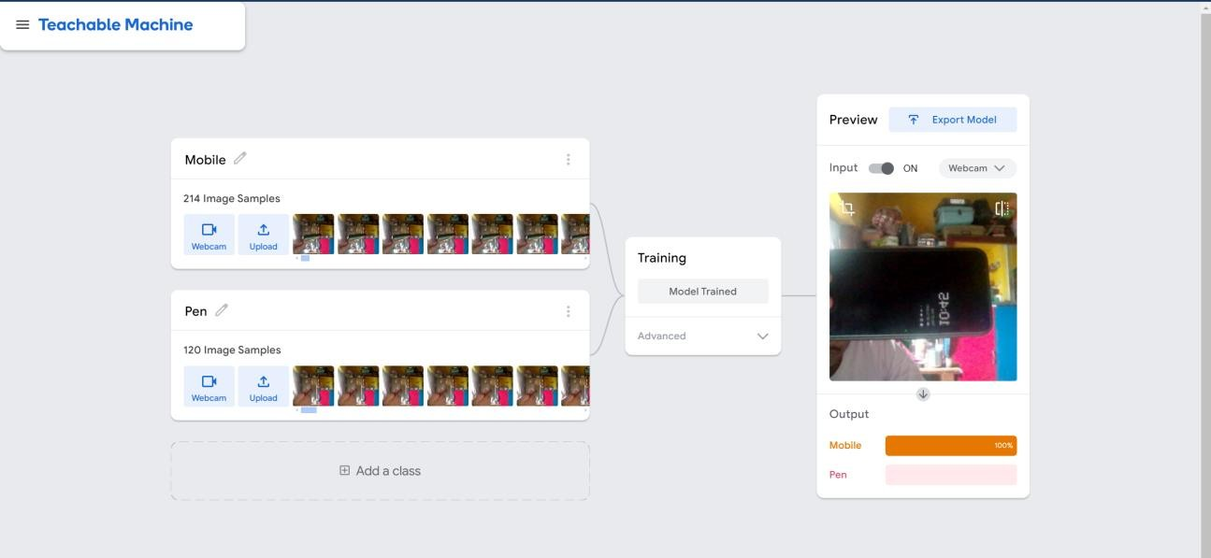

*Detecting the Object.*

#### Advantages of Google Teachable Machine:

* + Easy to train and deploy
  + Very little time taken to train the model

# Image Object Detection:

The task of detecting instances of objects of a certain class within an image.

Object detection is a computer vision task that involves identifying and locating objects in images or videos. It is an important part of many applications, such as self-drivingcars, robotics, and video surveillance.

Over the years, many methods and algorithms have been developed to find objects inimages and their positions. The best quality in performing these tasks comes from using convolutional neural networks.

One of the most popular neural networks for this task is YOLO, created in 2015 byJoseph Redmon, Santosh Divvala, Ross Girshick, and Ali Farhadi in their famous research paper "You Only Look Once: Unified, Real-Time Object Detection".

Since that time, there have been quite a few versions of YOLO. Recent releases can do even more than object detection. The newest release is YOLOv8, which we are going touse in this tutorial.

The main features of this network for object detection is First, we will use a pre-trained model to detect common object classes like cats and dogs. Then, I will show how to train your own model to detect specific object types that you select, and how to prepare the data for this process. Finally, we will create a web application to detect objects on images right in a web browser using the custom trained model.

# Problems that YOLOv8 can solve:

We can use the YOLOv8 network to solve classification, object detection, and image segmentation problems. All these methods detect objects in images or in videos in differentways, as you can see in the image below:

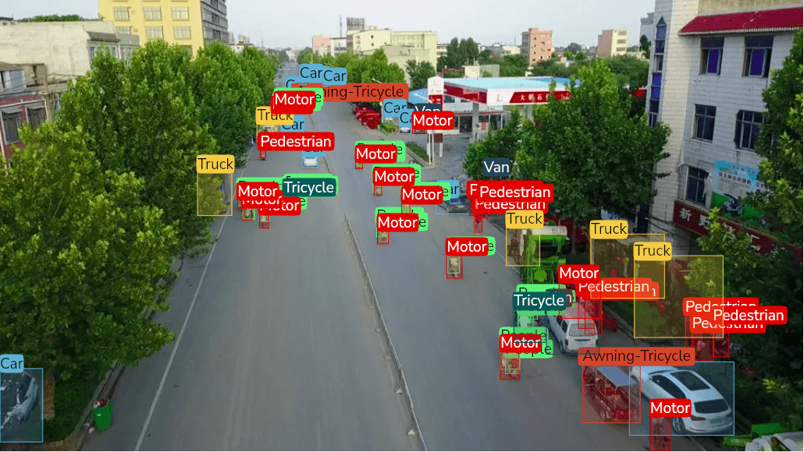

*Common Computer Vision Problems-Classification, Detection, and Segmentation*

The neural network that's created and trained for image classification determines a class ofobject on the image and returns its name and the probability of this prediction.

For example, on the left image, it returned that this is a "cat" and that the confidence level of thisprediction is 92% (0.92).

The neural network for object detection, in addition to the object type and probability, returnsthe coordinates of the object on the image: x, y, width and height, as shown on the second image.Object detection neural networks can also detect several objects in the image and their bounding boxes.

Finally, in addition to object types and bounding boxes, the neural network trained for imagesegmentation detects the shapes of the objects, as shown on the right image.

# Object Detection using YOLOv8:

To get started, create a free Roboflow account.

After reviewing and accepting the terms of service, you will be asked to choose between one of two plans: the Public Plan and the Starter Plan. Choose the public plan and enter a name tothe workspace. After click on create workspace.

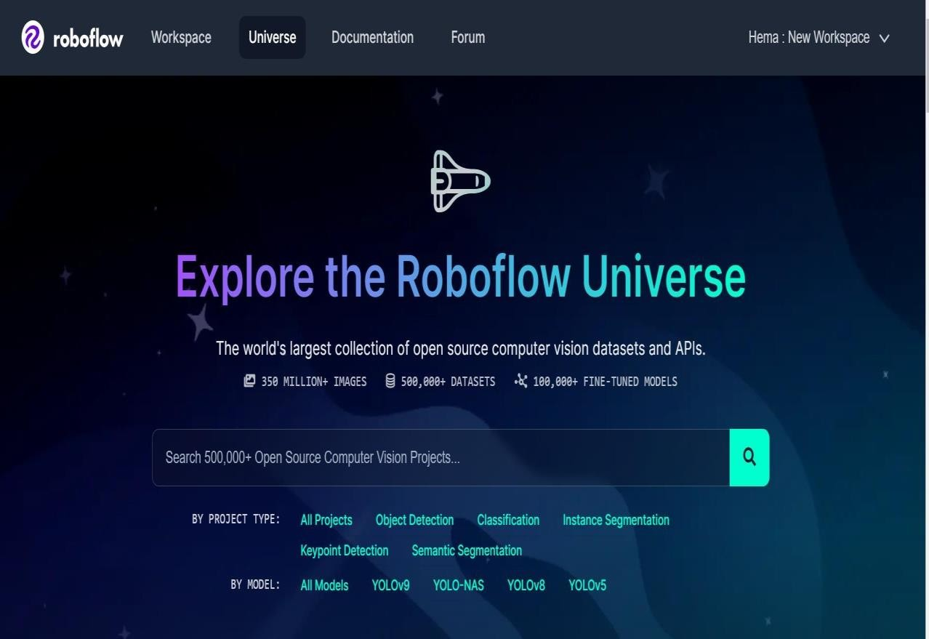

Then, you will be asked to invite collaborators to your workspace. These collaborators canhelp you annotate images or manage the vision projects in your workspace. Once you have invited people to your workspace (if you want to), you will be able to create a project.

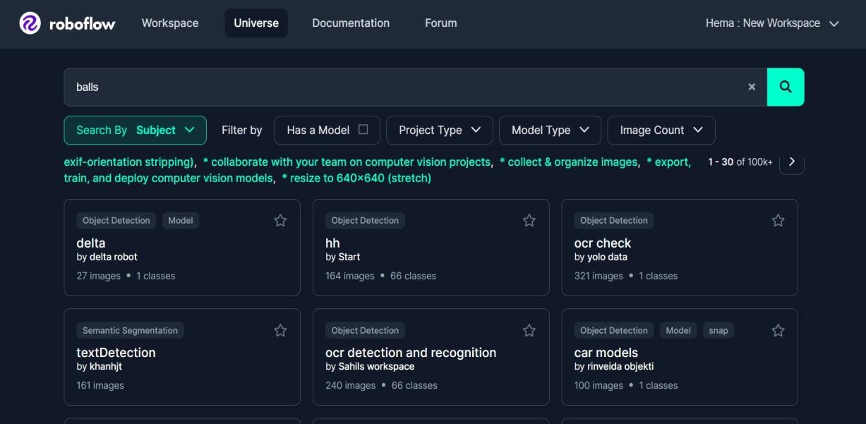

For this example, we will be using a dataset of cars to train a model that can identify screws in a kit. This model could be used for quality assurance in a manufacturing facility. With thatsaid, you can use any images you want to train a model.

Leave the project type as the default "Object Detection" option since our model will beidentifying specific objects and we want to know their location within the image.

Click “**Create Project**.” to continue.

Paste the youtube link and then click next it will process the video here the video is nothingbut a series of images here we will take 1 frame/second then click on choose frame rate.

Now click on universe and click on self-driving there are 100 of datasets select “vehiclesComputer Vision Project” click on download this dataset. In format select YOLOv8

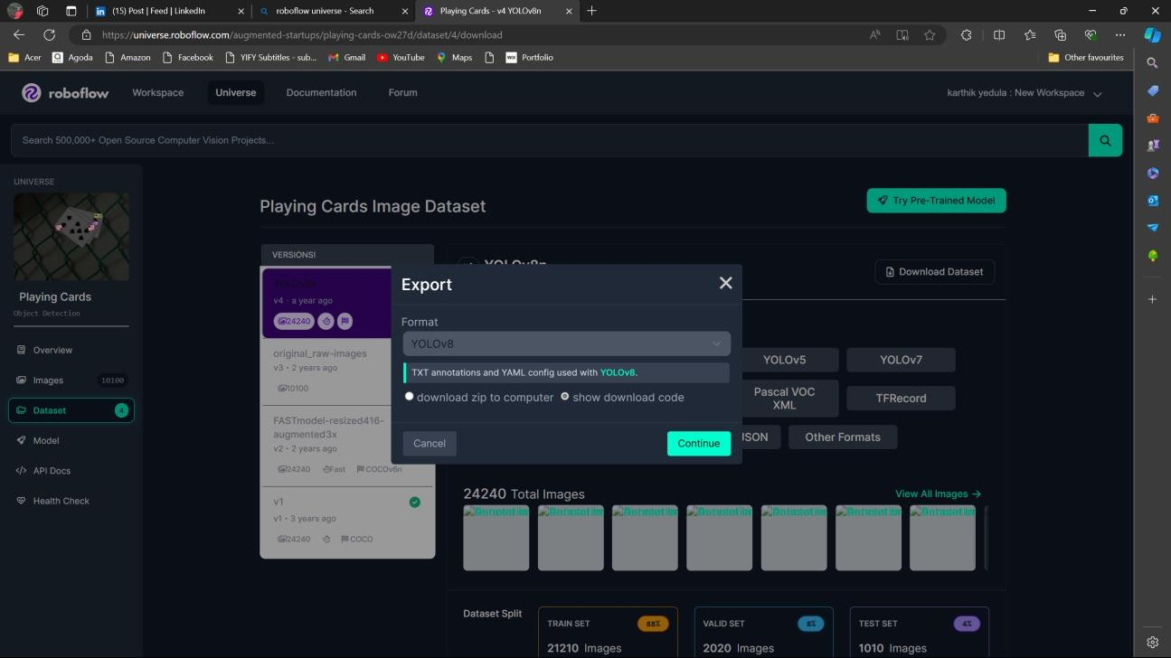

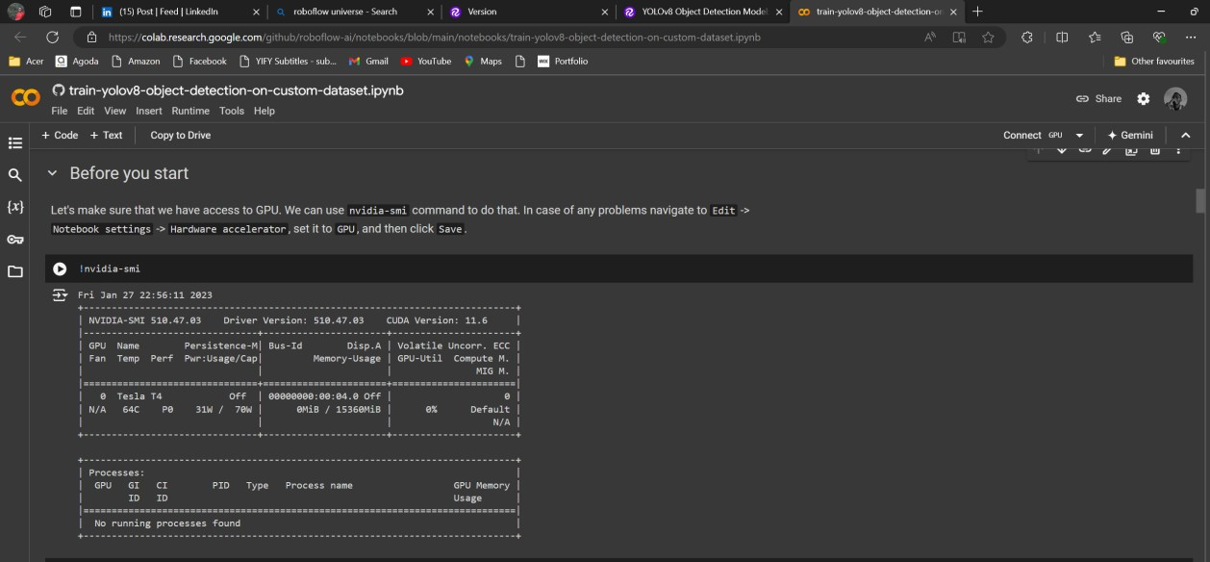After selecting YOLOv8 click on continue. Copy the code now click on a notebook from your model library select YOLOv8 after clicking YOLOv8 you can see Train on colab on theright-side open train on colab. Here you can see the following codes:

Now run the cell. This cell is used to check whether you have connected to GPU (Graphics Processing Unit) or not.

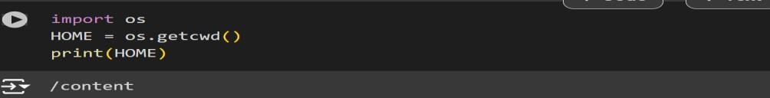

Now run the above cell this cell works the current directory to home.

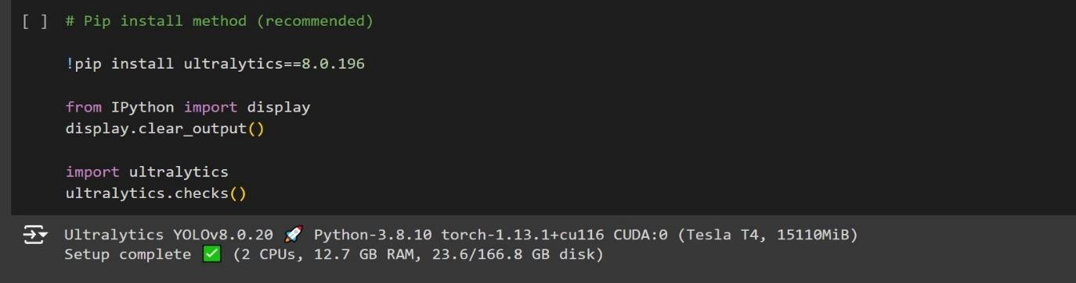

Run the above cell it will install the YOLOv8

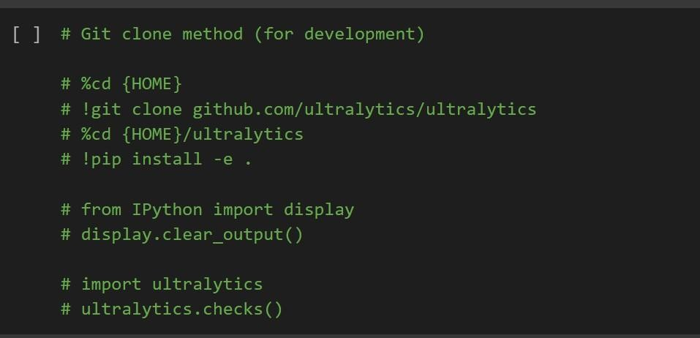

No need to execute the above cell.

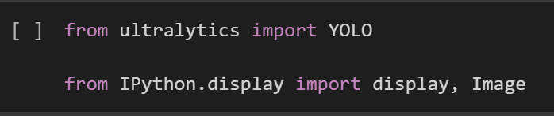

Run the above cell this cell will import yolo. After executing the four cells scroll down youwill find a cell in Preparing a custom dataset. After step 5 you can see a cell

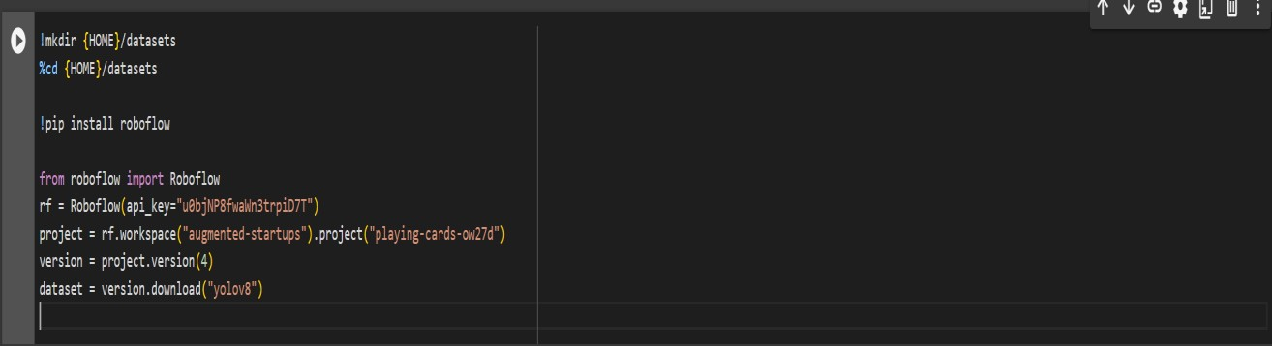



Now run the Custom Training cell

After running the above cell you can upload the image or video so that it can label all theobjects. In runs-detect-train download the best.pt file this file is the model file

Now run Inference with custom model



After running the above cell the result will be saved in runs/detect/predict

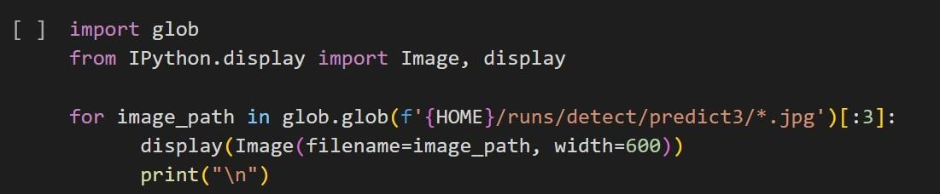

After running the above cell the below output is generated. Paste the video link in source After running the cell.

You will find the video with the detecting of objects using YOLOv8.



After running the above cell you will find the result video in runs/detect/predict2.

# Connecting to google drive:

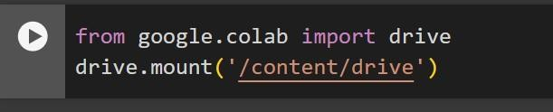

After running the above cell you can find the result video in your google drive.

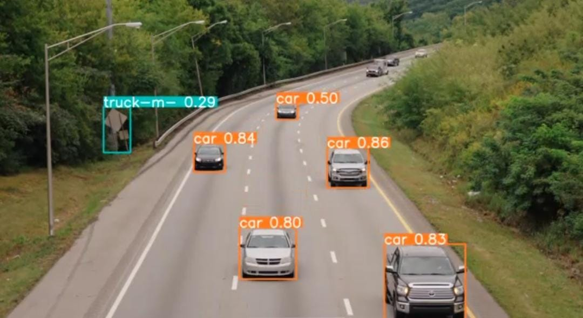

# Medical Image Analysis and Labelling:

Medical image analysis and labelling involve several key steps and considerations to ensure accuracy and effectiveness in diagnosing and treating medical conditions. Here’s an overviewof the process:

#### Steps in Medical Image Analysis and Labelling:

1. **Image Acquisition:**

-**Modality:** Collect images from various medical imaging modalities like MRI, CT,X-ray, ultrasound, PET, etc.

-**Quality:** Ensure high-quality images with minimal noise and artifacts.

#### Preprocessing:

* + **Normalization:** Standardize image intensity values.
  + **Noise Reduction:** Apply filters to reduce noise.
  + **Segmentation:** Identify and isolate regions of interest (ROIs), such as organs,tissues, or tumors.
  + **Registration:** Align images from different time points or modalities.

#### Annotation and Labelling:

-**Manual Labelling:** Radiologists or medical experts annotate images by outlining ormarking regions.

-**Automated Labelling:** Use algorithms and AI models to automatically label regionsbased on learned patterns.

-**Semi-Automated Labelling:** Combine manual and automated techniques to improve efficiency and accuracy.

#### Feature Extraction:

* **Morphological Features:** Shape, size, and structure of anatomical regions.
* **Textural Features:** Patterns within tissues.
* **Functional Features:** Information from dynamic studies, such as blood flow.

#### Classification and Analysis:

* **Machine LearningModels:** Train classifiers to differentiate between normal andpathological tissues.
* **Deep Learning Models:** Use neural networks, especially convolutional neural networks (CNNs), for complex pattern recognition.

#### Validation and Testing:

* **Cross-Validation:** Ensure the model's robustness by validating on different subsetsof data.
* **Accuracy Metrics:** Evaluate using sensitivity, specificity, precision, recall, F1 score,and ROC-AUC.

#### Interpretation and Reporting:

* **Visualization:** Provide visual representations like heat maps to highlight areas ofinterest.
* **Reporting:** Generate comprehensive reports with annotated images and diagnosticinsights.

***Tools and Software for Medical Image Analysis:***

* **3D Slicer:** Open-source software for visualization and analysis of medical images.
* **ITK-SNAP:** Tool for segmentation of 3D medical images.
* **Fiji (ImageJ):** Image processing package suitable for medical image analysis.
* **NVIDIA Clara:** AI toolkit for medical imaging.
* **Deep Learning Frameworks:** TensorFlow, PyTorch, Keras for building custom AImodels.

## Challenges and Considerations:

* **Data Quality:** High-quality, well-annotated datasets are crucial for trainingeffective models.
* **Ethics and Privacy:** Ensure compliance with regulations like HIPAA for patient dataprivacy.
* **Interoperability:** Standardize formats (e.g., DICOM) for compatibility acrosssystems.
* **Expert Collaboration:** Engage medical experts in the annotation and validationprocesses.
* **Model Interpretability:** Develop models that are interpretable to ensure trust andclinical acceptance.

## Future Directions:

* **Integrating Multimodal Data**: Combining data from various imaging techniquesand other sources (e.g., genomic data).
* **Real-Time Analysis**: Enhancing real-time image analysis for applications like surgery.
* **Personalized Medicine**: Tailoring analysis and treatment based on individual patientdata.

**- Cloud-Based Solutions**: Leveraging cloud computing for scalable and accessibleimage analysis.

## Conclusion:

Medical image analysis and labelling are critical components of modern healthcare, leveraging advanced techniques and technologies to improve diagnostic accuracy and patientoutcomes. By addressing challenges and leveraging emerging trends, the field continues to evolve, offering new possibilities for personalized and precise medical care.

## Lung cancer detection:

Lung cancer object detection involves using advanced image analysis techniques to identifyand classify lung nodules and other potential cancerous regions in medical imaging, such asCT scans. Lung cancer object detection leverages advanced imaging and machine learning techniques to improve early detection and diagnosis. By addressing the challenges and continuously evolving the methodologies, the field aims to enhance patient outcomes and support clinicians in making more informed decisions.

# Human Pose Estimation:

**Pose Estimation** is a computer vision task where the goal is to detect the position and orientation of a person or an object. Usually, this is done by predicting the location of specifickey points like hands, head, elbows, etc. in case of Human Pose Estimation.

A common benchmark for this task is [MPII Human Pose](https://paperswithcode.com/sota/pose-estimation-on-mpii-human-pose). Human pose estimation involvesdetecting and tracking the positions of key body joints in images or video frames. This technology has applications in various fields such as healthcare, sports, animation, and human-computer interaction.

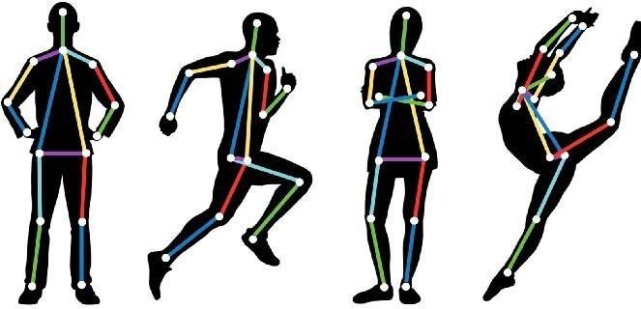

# Conclusion:

Human pose estimation is a rapidly advancing field with significant applications across various industries. By leveraging advanced machine learning techniques and addressing the inherent challenges, pose estimation technology continues to improve, offering new possibilities for human-centered applications.

# Mediapipe Studio: Hand Gestures:

MediaPipe Studio is a web-based application for evaluating and customizing on-device ML models and pipelines for your applications. The app lets you quickly test MediaPipe solutionsin your browser with your own data, and your own customized ML models. MediaPipe Studio is a powerful tool for building, visualizing, and deploying machine learning pipelines, particularly those involving real-time processing of video and audio data. It is part of the MediaPipe framework developed by Google, which offers a collection of cross-platform, customizable ML solutions. Here's an in-depth look at MediaPipe Studio, its features, capabilities, and applications:

## Key Features of MediaPipe Studio:

#### Modularity and Customizability:

* **Building Blocks**: MediaPipe Studio provides a set of modular components that canbe combined to create complex pipelines. These components include detectors, trackers, classifiers, and more.
* **Custom Graphs**: Users can design custom data processing graphs by connectingvarious components, enabling the creation of bespoke ML solutions.

##### Real-Time Processing:

* **Optimized Performance:** MediaPipe is designed for real-time performance, capableof processing video and audio streams with low latency.
* **Multi-Platform Support**: It supports deployment on multiple platforms, including mobile (Android, iOS), desktop (Linux, macOS, Windows), and web.

##### Pre-Built Solutions:

* **Human Pose Estimation**: Accurate detection and tracking of human bodykey points.
* **Hand Tracking**: High-fidelity hand and finger tracking.
* **Face Detection and Mesh**: Real-time face detection, landmark tracking, and meshgeneration.
* **Object Detection**: General object detection models for various use cases.
* **Holistic Tracking**: Combined body, face, and hand tracking.

##### Visualization Tools:

* **Graph Visualization**: Tools to visualize the data flow and component interactionswithin custom graphs.
* **Debugging and Tuning**: Features to debug and fine-tune individual components andthe overall pipeline.

##### Cross-Platform Deployment:

* **Mobile Integration**: Seamless integration with Android and iOS applications usingMedia Pipe’s mobile APIs.
* **Web Support**: Using Web Assembly (Wasm) and WebGL, MediaPipe solutions canrun efficiently in web browsers.

## Applications of MediaPipe Studio:

#### Healthcare:

* **Pose-Estimation**: For physical therapy, posture correction, and monitoring ofpatients.
* **Hand Tracking**: For hand hygiene monitoring and gesture- based interfaces inmedical applications.

##### Sports and Fitness:

* **Performance Analysis**: Tracking athlete movements to analyze and improveperformance.
* **Virtual Coaching**: Providing real-time feedback and guidance during workouts.

##### Entertainment and Media:

* **AR/VR**: Enhancing AR/VR experiences with accurate body and hand tracking.
* **Content Creation**: Facilitating the creation of interactive and immersive mediacontent.

##### Human-Computer Interaction:

* **Gesture Recognition**: Developing gesture-based control systems for devices andapplications.
* **Facial Recognition**: For user authentication and emotion detection.

##### Robotics:

* + **Human-Robot Interaction**: Enabling robots to understand and respond to humangestures and movements.
  + **Autonomous Navigation**: Using object detection and tracking for navigation andobstacle avoidance.

## Conclusion:

MediaPipe Studio provides a robust framework for developing and deploying machine learning pipelines with a focus on real-time video and audio processing. Its modularity, cross- platform support, and extensive pre-built solutions make it a versatile tool for a wide range ofapplications. By leveraging MediaPipe Studio, developers can create sophisticated ML solutions that enhance interactivity, efficiency, and user experience across various domains.

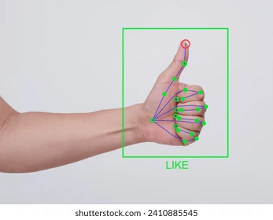*Hand gesture using MediaPipe Studio*

# Chatbot Development:

Creating interactive agents that can converse with humans using natural language.

##### Creating a new Chatbot

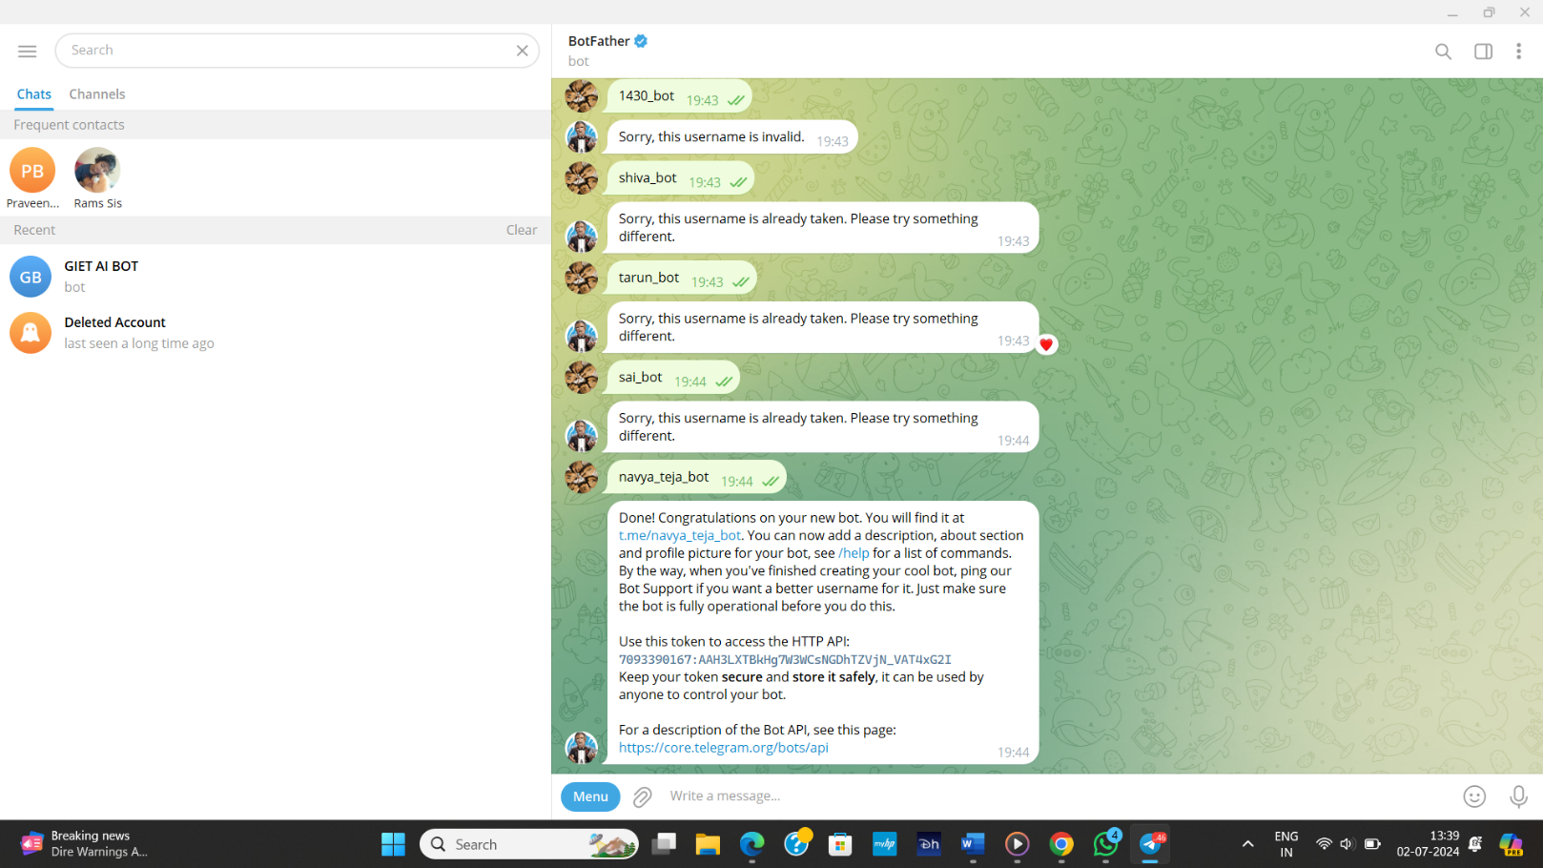Go to telegram app, log in to your account, Type in @BotFather in the search field, and go to this bot.

Click Start to activate the BotFather Chatbot.

You will receive a list of commands you can use to manage bots. Select or type in the /newbot command, and send i

Choose a name for your bot — your subscribers will see it during your conversations. Youalso need to pick a username for your bot so that users can find it using search. Your bot username must be unique and end with the word bot.

Once you choose a name for your chatbot, it will be created. You will receive a message witha link to your bot (t.me/<bot_username>), recommendations on how to set up a profile picture, description, and a list of commands you can use to manage your new bot.

To connect to your bot you need to copy the token and place in TelegramBOT TOKEN.

Now run the above cell.

Generate API key and paste in genai.configure and run the cell.

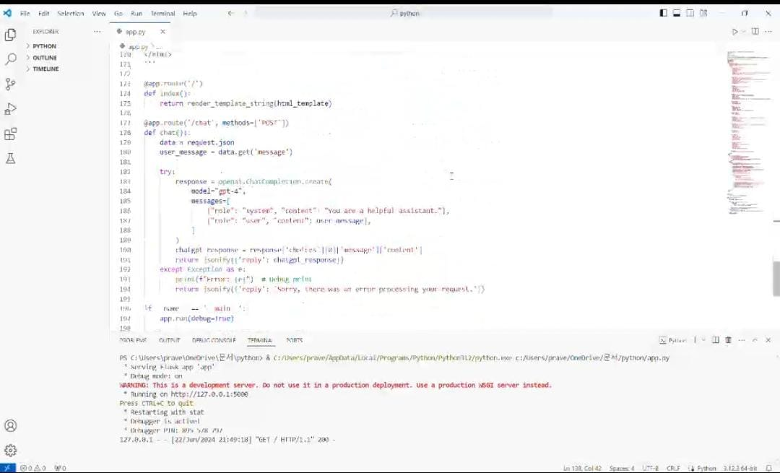

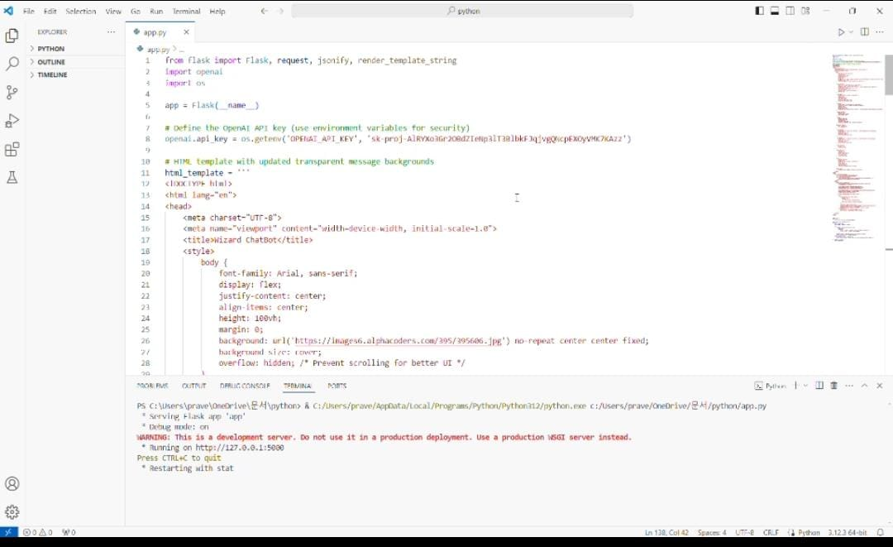



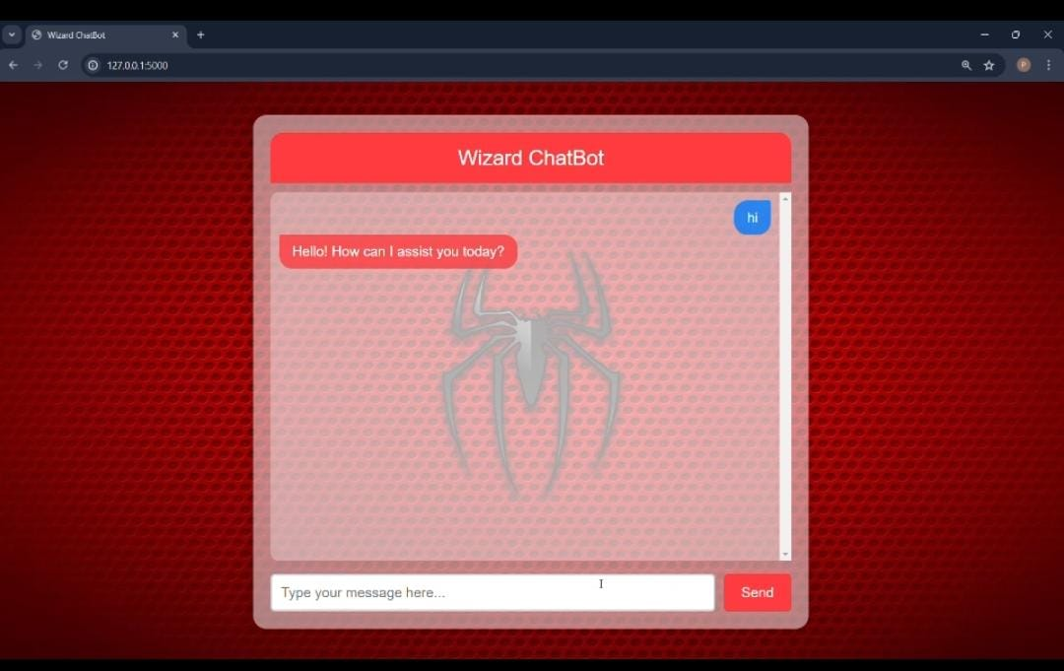

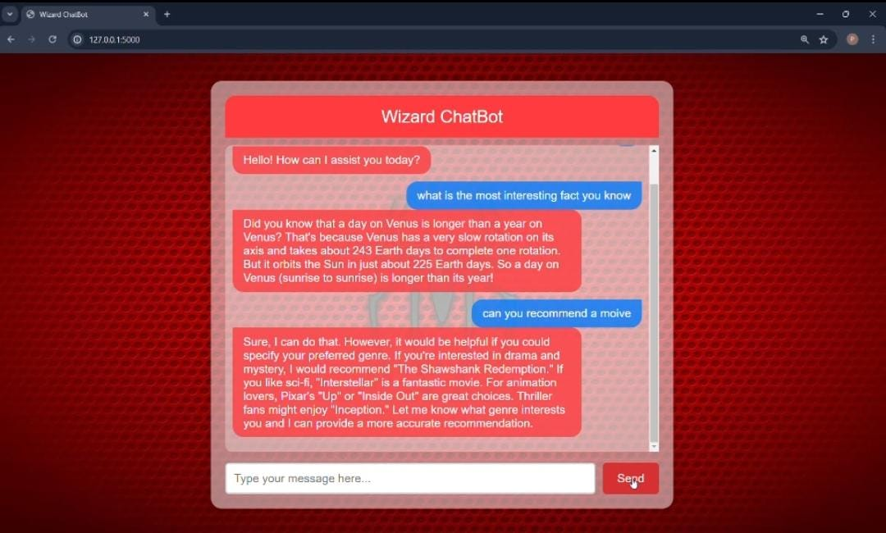

# Google Dialogflow:

Google Dialogflow is a powerful tool for building conversational interfaces, including Chatbot, voice assistants, and other types of interactive applications. It uses natural languageunderstanding (NLU) to process and interpret user input, enabling developers to create responsive and engaging conversations.

##### Key Features of Google Dialogflow:

* 1. **Natural Language Processing (NLP):** Dialogflow uses advanced NLP algorithms to understand the intent behind user queries, enabling more accurate and natural interactions.
  2. **Multi-platform Support:** You can deploy Dialogflow agents across various platforms, including websites, mobile apps, messaging platforms (like Facebook Messenger and Slack),and voice assistants (like Google Assistant and Amazon Alexa).
  3. **Integration Capabilities:** Dialogflow offers integrations with various services and APIs,allowing you to connect your chatbot or voice assistant with databases, CRM systems, and other backend services.
  4. **Prebuilt Agents and Templates:** It provides prebuilt agents and templates for commonuse cases, making it easier to get started with your conversational interface.
  5. **Rich Fulfillment:** Dialogflow supports rich fulfillment capabilities, including sendingimages, buttons, and other interactive elements in responses.
  6. **Context Management:** It allows for maintaining context in conversations, enabling thecreation of more complex and dynamic interactions.
  7. **Training and Testing Tools:** Dialogflow includes tools for training and testing your agents, helping to improve their accuracy and performance over time.
  8. **Analytics and Reporting:** It provides detailed analytics and reporting features to monitorand analyze the performance of your agents.

##### Getting Started with Dialogflow:

1. **Create a Dialogflow Account:** Sign up for Dialogflow using your Google account.
2. **Create an Agent:** An agent is a virtual agent that handles conversations with end-users.You can create a new agent from the Dialogflow console.
3. **Define Intents:** Intents represent the actions users want to perform. You define intentsbased on user inputs and map them to corresponding responses.
4. **Train Your Agent:** Train your agent with various example phrases so it can accuratelyrecognize user intents.
5. **Integrate with Platforms:** Use Dialogflow's integrations to deploy your agent on variousplatforms.
6. **Test and Iterate:** Continuously test and refine your agent to improve its accuracy and userexperience.

##### Use Cases:

* **Customer Support:** Automate responses to common customer queries, reducing theworkload on human agents.
* **E-commerce:** Assist customers with product searches, order tracking, and personalizedrecommendations.
* **Healthcare**: Provide patients with information on medical conditions, appointment scheduling, and medication reminders.
* **Education:** Help students with homework, course information, and administrative tasks.

Google Dialogflow is a versatile tool that can significantly enhance user interaction with yourapplication, making it more intuitive and responsive to user needs.

# Generative AI:

Techniques and models used to generate new content such as music, text, and images

**- Music Generation:** Creating music using AI models.

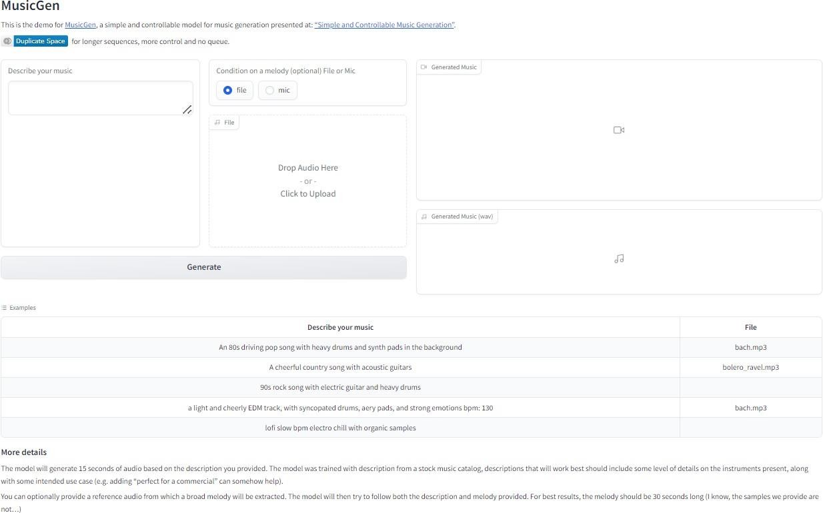*Music Generation using MusicGen*

* **Text Generation:** Producing coherent and contextually relevant text using AI.

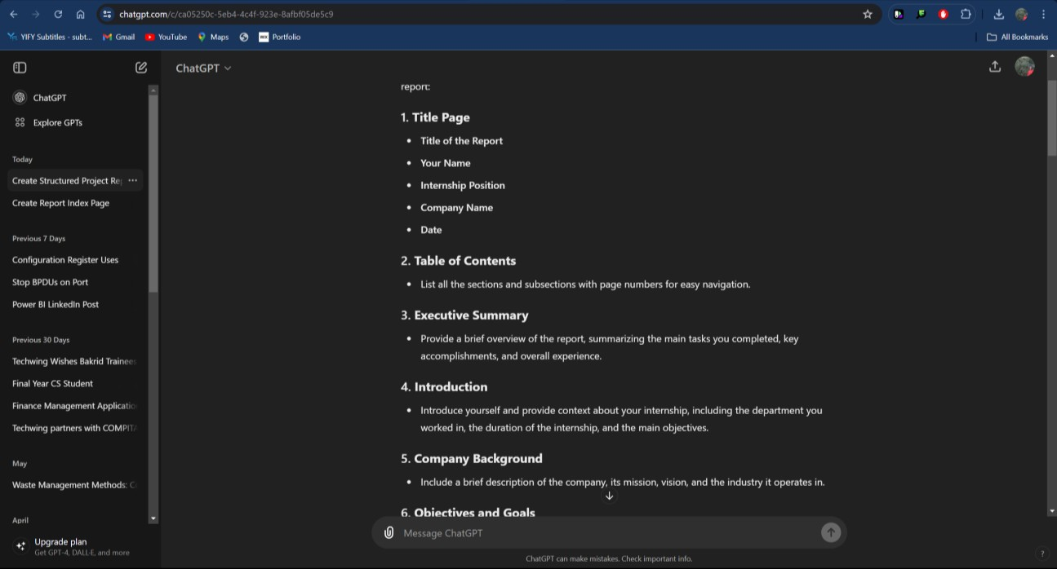

*Text Generation using ChatGPT*

* **Image Generation Models:** Generating new images using AI techniques.



*Cat playing in a garden.*

# Visual Question & Answering:

Various models used for different AI applications.

**-Summarization:** Creating concise summaries of larger texts.

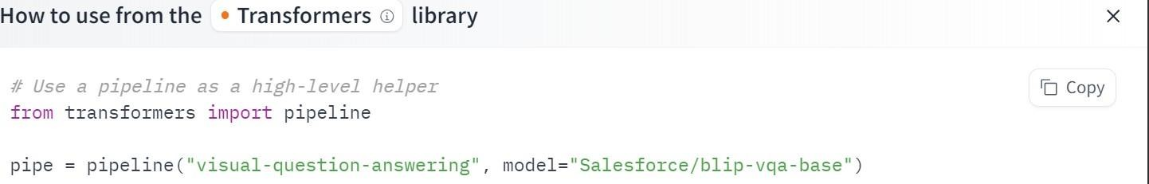

#### Output:

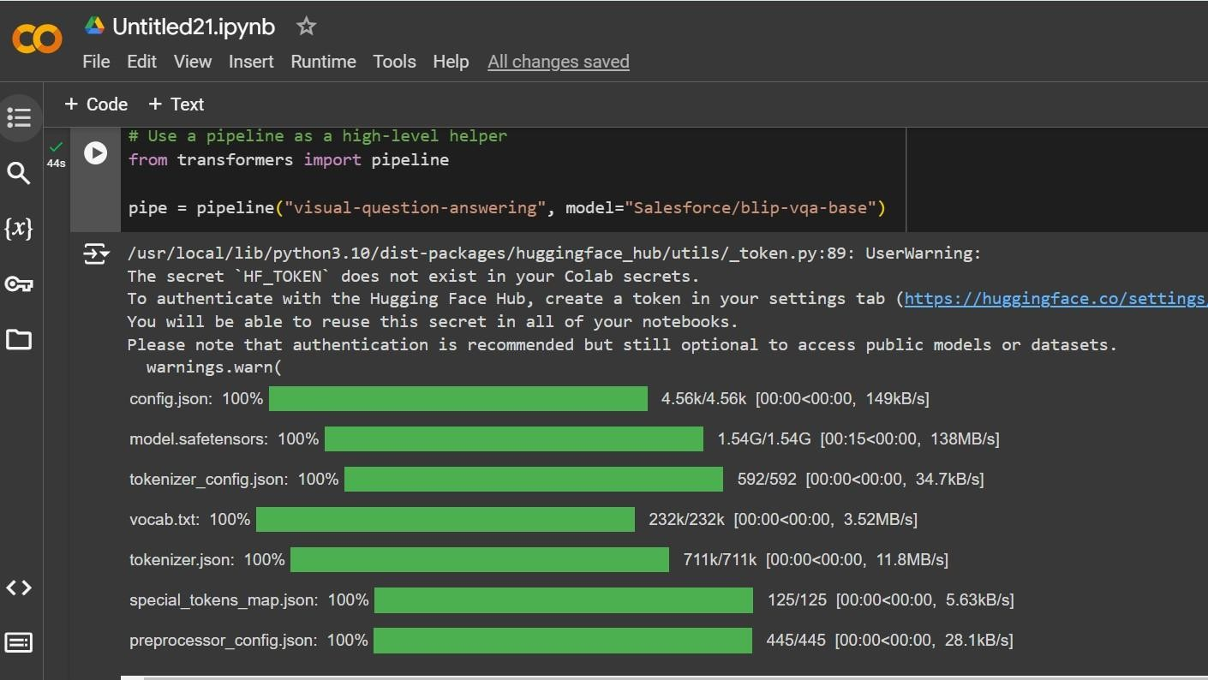

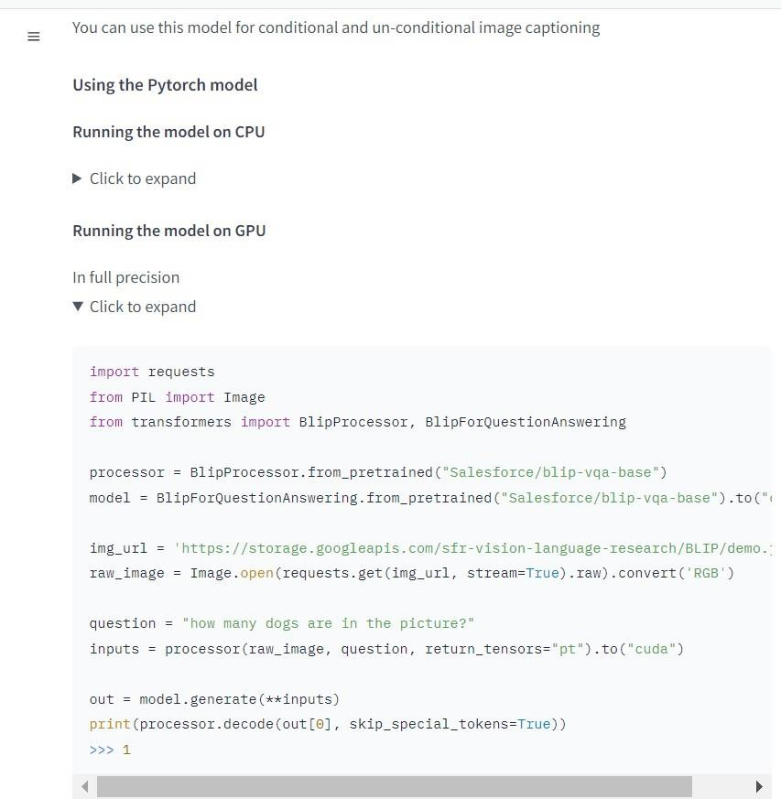

**-Fill Mask Model:** Predicting masked words within a sentence.

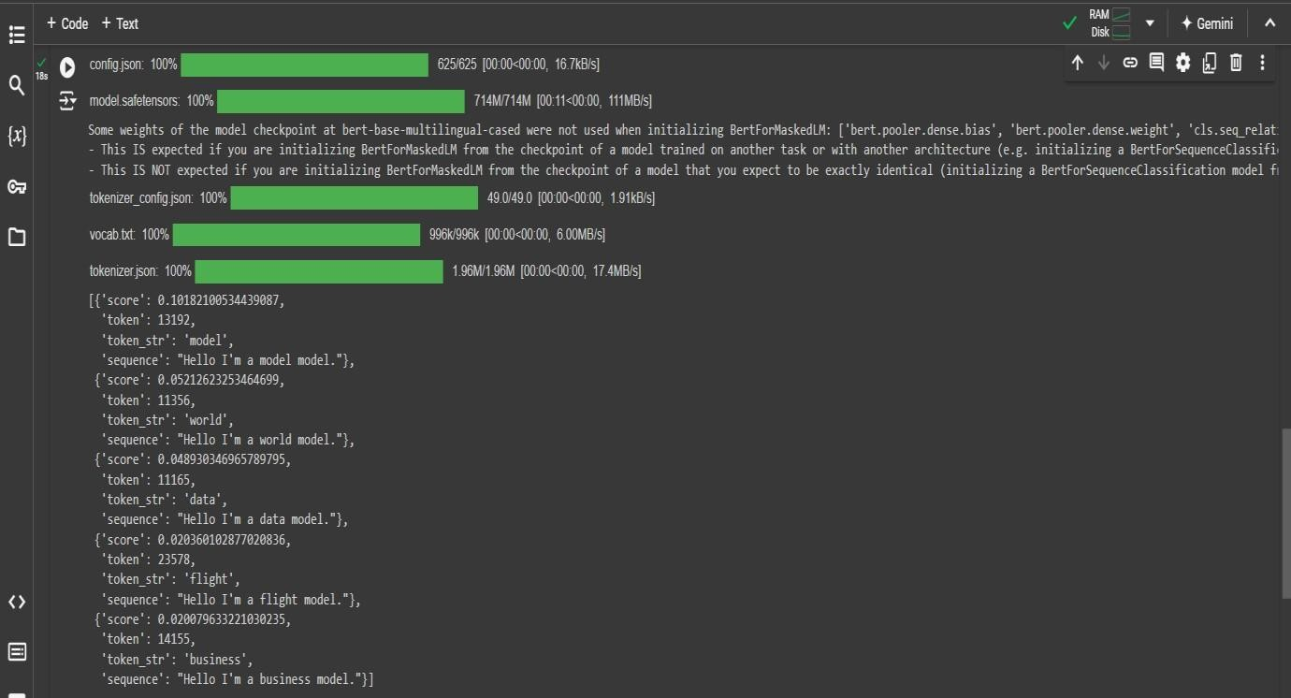

# Table Question & Answering:

Models that answer questions using tabular data.

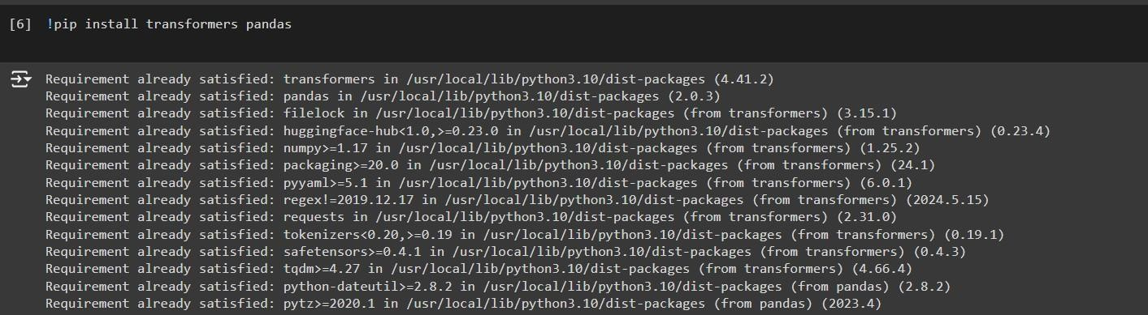

# Output:

1. **Large Language Models:**

Advanced language models that understand and generate human-like text.

* **Claude:** A large language model known for its performance in text generation.
* **GPT:** Generative Pre-Trained Transformer, a state of-the-art language model.
* **G(Generative):** GPT can develop coherent and contextually relevant text based on thegiven prompt.
* **P(Pre-trained):** Pre-training phase is when GPT gains language understanding bypredicting the next word in sentences.
* 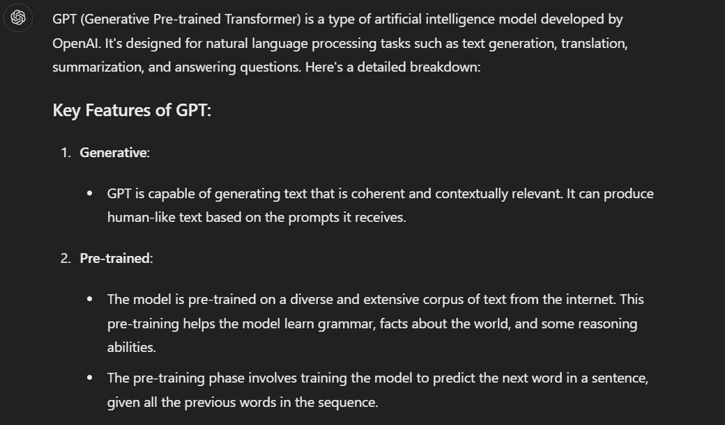**T(Transformer):** GPT is based on the transformer architecture, a type of neural networkarchitecture that excels at processing sequential data.

*An illustration of how GPT processes user prompts to deliver informative responses.*

* **Gemini:** An AI model focused on text and language understanding

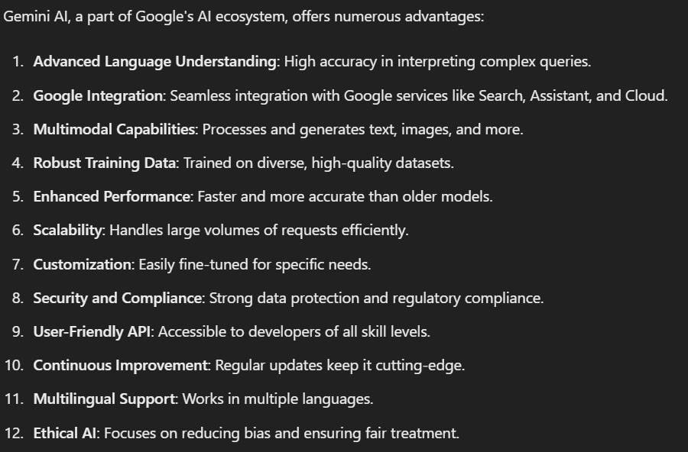

* **LLaMA3:** A large language model by meta AI.
* **OpenLLMs:** Various open-source large language models.

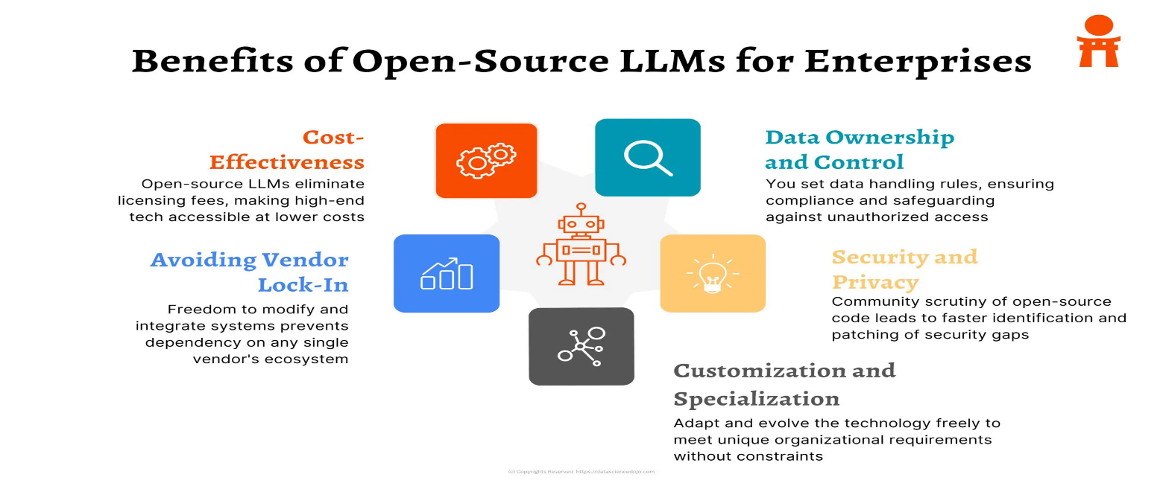

# Other Topics:

**Using Vision API**: Implementing Google's Vision API for image analysis.

* **Small Language Models (SLMs) - BERT, GPT:** Efficient language models forvarious NLP tasks.
* **Ultralytics Hub:** A platform for deploying and managing AI models.
* **TensorFlow Lite Models:** Lightweight models for mobile and embedded devices.
* **Sentiment Analysis:** Determining the sentiment expressed in a piece of text.
* **Deepfakes:** Synthetic media where a person in an existing image or video is replacedwith someone else's likeness.

# List of Topics in Cyber Security:

|  |  |
| --- | --- |
| **Si.No.** | **Topics** |
| 1 | *Cyber Security Basics* |
| 2 | *Types of Cyber Crimes* |
| 3 | *CIA Traid* |
| 4 | *AAA Framework* |
| 5 | *OWASP(Open Web Application Security*  *Project)* |
| 6 | *SQL Injection* |
| 7 | *Cross site scripting(XSS)* |
| 8 | *Firewall* |
| 9 | *Vulnerability Scanner* |

1. **Cyber Security Basics:**

Fundamental principles and practices for protecting computer systems and networks fromcyber threat.

##### Devices:

* + Use strong passwords for all your devices at least 12 characters
  + Set your software’s to update automatically this includes apps, web browsers, operatingsystems.
  + Backup your important files offline like cloud or external hard drive. If your devices contain personal information, make sure they are **encrypted** and require **Multi-Factor Authentication** to access areas of your network with sensitive information. This requiresadditional steps beyond logging in with a password- Like a temporary code on a smart phone or a key that’s inserted into a computer
  + Secure your router by changing its default name & password, turn off remote management, Login out as the administrator. Make sure that your router is using WPA2(or)WPA3 encryption which protects your information sent over your network soit can’t be read by outsiders.



-

# Types of Cyber Crimes:

Various forms of illegal activities conducted via internetBelow are some of the cyber- crimes:

1. **Phishing:** Phishing is a type of social engineering attack that targets the user and tricksthem by sending fake messages and emails to get sensitive information about the user or trying to download malicious software and exploit it on the target system.



1. **Ransomware:** [Ransomware attacks](https://cybertalents.com/blog/work-from-home-cybersecurity-tips-and-risks) are a very common type of cybercrime. It is a type of malware that has the capability to prevent users from accessing all of their personal data on the system by encrypting them and then asking for a ransom in order to give access tothe encrypted data.



1. **Internet Fraud:** Internet fraud is a type of cybercrimes that makes use of the internetand it can be considered a general term that groups all of the crimes that happen over the internet like spam, banking frauds, theft of service, etc.



# CIA Traid:

**C –** Confidentiality

**I –** Integrity

**A –** Availability

**Definition for CIA Traid:** A model designed to guide policies for information securitywithin an organization.

**Confidentiality:** Ensuring that information is accessible only to those authorized to haveaccess.

**Integrity:** Maintaining the accuracy and completeness of data. **Availability:** Ensuring that authorized users have access to information and resourceswhen needed.

##### Importance of CIA Traid:

Confidentiality protects sensitive information from unauthorized access.Integrity ensures data is trustworthy and accurate.

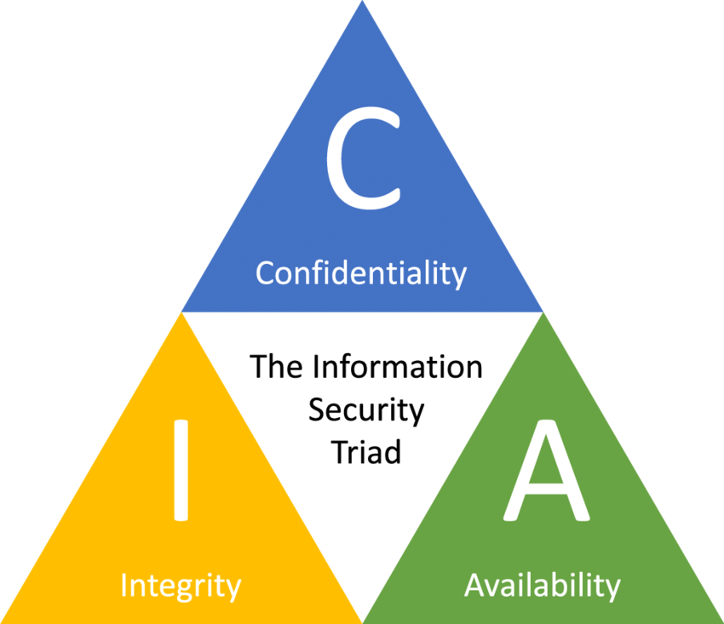Availability guarantees that information and resources are accessible when needed byauthorized users.

# AAA Framework:

The AAA (Authentication, Authorization, Accounting) framework is a fundamental securityarchitecture widely used in network and computer security to manage and enforce access control and auditing. Here's an overview of each component of the AAA framework:

##### Authentication:

* + - **Definition:** Authentication is the process of verifying the identity of a user, device, orentity. It ensures that the entity requesting access is indeed who or what it claims to be.

##### Methods:

* + - **Password-based:** Users provide a username and password.
    - **Multi-Factor Authentication (MFA):** Combines two or more independent credentials(e.g., password, biometric, smart card).
    - **Biometric:** Uses unique biological characteristics (e.g., fingerprints, retina scans).
    - **Certificate-based:** Utilizes digital certificates issued by a trusted Certificate Authority(CA).

##### Authorization:

* + - **Definition:** Authorization determines what an authenticated user or entity is allowed todo. It involves granting or denying permissions based on predefined policies.

**Methods:**

* + - * **Role-Based Access Control (RBAC):** Permissions are assigned based on user roleswithin an organization.
        + **Attribute-Based Access Control (ABAC):** Permissions are granted based on attributes (e.g., user characteristics, resource types, environmental conditions).
        + **Access Control Lists (ACLs):** Lists that specify which users or system processes aregranted access to objects and what operations are allowed.

##### Accounting:

* + - **Definition:** Accounting, also known as auditing, involves tracking and recording useractivities and resource usage. This helps in monitoring, analysis, and reporting.

##### Methods:

* + - **Logging:** Recording user actions and access events in logs for future reference.
    - **Usage Monitoring:** Keeping track of resource consumption and usage patterns.
    - **Auditing:** Regularly reviewing logs and usage reports to ensure compliance and detectanomalies.

***Application of the AAA Framework:***

#### Network Security:

* + **Remote Access:** AAA is crucial for secure remote access through VPNs and remotedesktop services.
  + **Wireless Networks:** Used in securing Wi-Fi networks (e.g., WPA2-Enterprise) byverifying users and devices before allowing network access.

##### Cloud Services:

* + **Identity and Access Management (IAM):** Cloud providers use AAA principles tomanage user identities, permissions, and track activity.
  + **Multi-tenant Environments:** Ensures that users can only access their own data and applications.

##### Application Security:

* + **Web Applications:** AAA is implemented to control user access to various parts of anapplication based on user roles and permissions.
  + **APIs:** Ensures that only authenticated and authorized applications can interact with APIs.

##### Compliance and Auditing:

* + **Regulatory Compliance:** Organizations use accounting mechanisms to comply withregulations like GDPR, HIPAA, and PCI-DSS, which require detailed logs and access records.
  + **Security Audits:** Regular audits based on accounting data help in identifying securityissues and ensuring compliance with security policies.

##### AAA Protocols and Technologies:

* + **RADIUS (Remote Authentication Dial-In User Service):** A networking protocol providing centralized Authentication, Authorization, and Accounting management for userswho connect and use a network service.
  + **TACACS+ (Terminal Access Controller Access-Control System Plus):** Provides detailed accounting and auditing, separating all three components of AAA, often used inenterprise networks.
  + **LDAP (Lightweight Directory Access Protocol):** Used for accessing and maintaining distributed directory information services, often used in conjunction with AAA for authentication purposes.
  + **Kerberos:** A network authentication protocol designed to provide strong authentication forclient/server applications by using secret-key cryptography.

The AAA framework is essential for maintaining robust security in various systems, ensuringthat only authorized users gain access, their activities are appropriately controlled, and all actions are logged for accountability and auditing purposes.

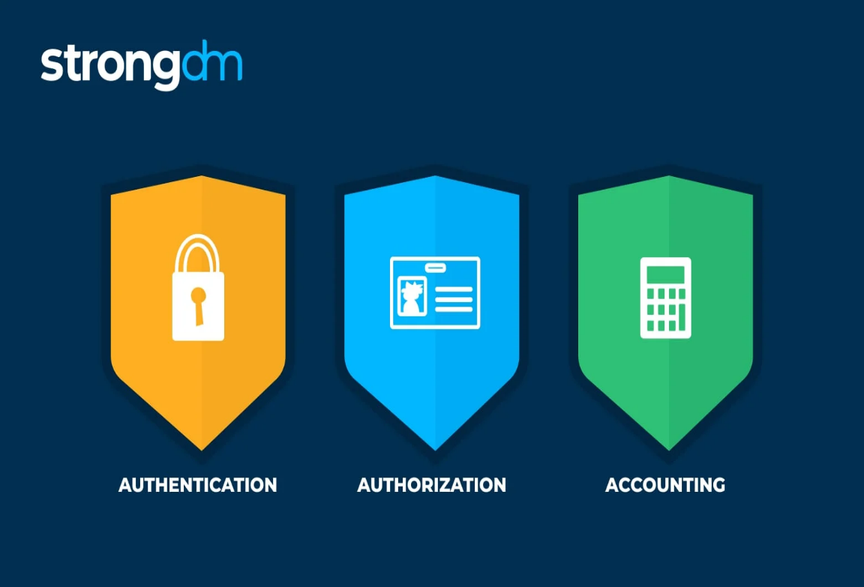

# OWASP(Open Web Application Security Project):

OWASP, the Open Web Application Security Project, is a non-profit organization dedicatedto improving the security of software. OWASP provides a wealth of free and open resourcesrelated to application security, including tools, documentation, and forums for discussing security issues. Here are some key aspects and resources provided by OWASP:

***Key Projects and Resources:***

1. **OWASP Top Ten:**

**- Definition:** The OWASP Top Ten is a regularly updated list of the top ten most criticalweb application security risks.

* **Purpose:** Raises awareness and provides guidance on how to mitigate these risks.

##### Current Top Ten Risks (as of the latest update):

* 1. Broken Access Control
  2. Cryptographic Failures
  3. Injection
  4. Insecure Design
  5. Security Misconfiguration
  6. Vulnerable and Outdated Components
  7. Identification and Authentication Failures
  8. Software and Data Integrity Failures
  9. Security Logging and Monitoring Failures
  10. Server-Side Request Forgery (SSRF)

1. **Broken Access Control:** A weakness that allows an attacker to gain access to useraccounts. The attacker in this context can function as a user or as an administrator in the system.
2. **Cryptographic Failures:** Cryptographic failures refer to vulnerabilities and securityrisks arising from the incorrect implementation, configuration, or use of cryptographic systems. These failures can compromise the confidentiality, integrity, and authenticity of data. They are among the most critical security risks.
3. **Injection:** Injection is a class of vulnerabilities where an attacker can send untrusted input to an application, which is then processed in an unsafe manner, leading to unintended behaviour. This can include accessing or modifying data, executing arbitrary commands, orotherwise compromising the application's security. Injection flaws are among the most critical security risks.
4. **Software and Data Integrity Failures:** Software and data integrity failures occur when software or data is compromised due to improper implementation, configuration, or lack of validation and verification mechanisms. These failures can lead to unauthorized codeexecution, data corruption, or system compromise.

##### Conclusion:

OWASP plays a crucial role in the field of web application security by providing essential resources, fostering community collaboration, and promoting best practices to mitigate security risks.

# SQl Injection:

##### What is SQL injection (SQLi):

SQL injection (SQLi) is a web security vulnerability that allows an attacker to interfere with the queries that an application makes to its database. This can allow an attacker to view data that they are not normally able to retrieve. This might include data that belongs to other users,or any other data that the application can access. In many cases, an attacker can modify or delete this data, causing persistent changes to the application's content or behavior.

In some situations, an attacker can escalate a SQL injection attack to compromise the underlying server or other back-end infrastructure. It can also enable them to perform denial-of-service attacks.

##### SQL Injection (SQLi):

* **Description:** Occurs when an attacker is able to manipulate SQL queries by injecting malicious input into them.
* **Example**: An attacker inputs '; DROP TABLE users; --in a form field, which can delete the entire users table if the input is not properly sanitized.

##### Some of the common types of SQL Injection: 1.Classic SQL Injection:

* If a login form directly includes user input as a SQL query:

SELECT * FROM users WHERE username = 'admin' AND password = 'password';

##### Blind SQL injection:

When an application doesn’t return error messages but behavior changes can be inferred.An attacker might use conditional statements to extract data.

SELECT * FROM users WHERE id = 1 AND (SELECT SUBSTRING(password, 1, 1)

FROM users WHERE username='admin') =

'a';

##### Error-Based SQL Injection:

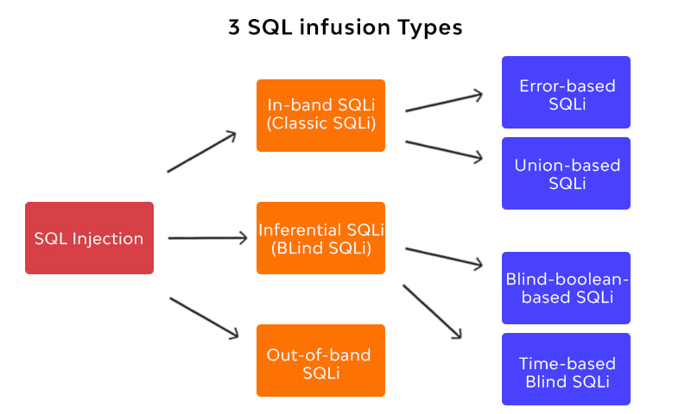

Error-based [SQL injection](https://brightsec.com/blog/sql-injection-sqli/) is an In-band injection technique that enables threat actors to exploit error output from the database to manipulate its data. It manipulates the database into generating an error thatinforms the actor of the database’s structure.

In-band injection enables threat actors to utilize one communication channel to launch an attack and retrieve data. It requires using a vulnerability to force data extraction. Typically, the vulnerability allows code to output an SQL error from the server instead of the required data. This error enables theactor to understand the entire database structure.

# Cross Site Scripting(XSS):

Cross-Site Scripting (XSS) attacks are a type of injection, in which malicious scripts are injected into otherwise benign and trusted websites. XSS attacks occur when an attacker usesa web application to send malicious code, generally in the form of a browser side script, to a different end user. Flaws that allow these attacks to succeed are quite widespread and occur anywhere a web application uses input from a user within the output it generates without validating or encoding it.

An attacker can use XSS to send a malicious script to an unsuspecting user. The end user’s browser has no way to know that the script should not be trusted, and will execute the script. Because it thinks the script came from a trusted source, the malicious script can access any cookies, session tokens, or other sensitive information retained by the browser and used withthat site. These scripts can even rewrite the content of the HTML page.

***Types of Cross site-scripting:***

* 1. **Stored XSS (Persistent XSS):**
     + **Description**: Malicious script is permanently stored on the target server,such as in a database, a message forum, or a comment field.
     + **Example:** An attacker posts a malicious script in a forum comment, which is then viewed by any user accessing that comment.

##### Reflected XSS (Non-Persistent XSS):

* + - **Description:** Malicious script is reflected off a web server, such as in an error message, search result, or any other response that includes input sent tothe server.
    - **Example:** An attacker sends a victim a link with a malicious script embedded in the URL. When the victim clicks the link, the script is executed in their browser.

##### DOM-Based XSS:

* + - **Description:** The vulnerability exists in client-side scripts that modify theDOM (Document Object Model) based on user input.
    - **Example**: An attacker manipulates a client-side script to execute arbitrarycode by altering the DOM environment in the victim’s browser.

#### How XSS Attacks Work

1. *Injection****:***
   * The attacker injects malicious code into a web application. This can be through input fields, URL parameters, or other means of sending data to theapplication.
2. *Execution****:***
   * The injected code is executed in the context of the user's browser when theyview the affected page.
3. *Impact****:***
   * The malicious script can perform any actions that the user can perform, accessany data that the user can access, and manipulate the content displayed to the user.

#### Consequences of XSS Attacks:

* **Session Hijacking**: Stealing session cookies to impersonate the user.
* **Credential Theft**: Stealing user credentials or other sensitive information.
* **Defacement**: Altering the content of the website.
* **Phishing**: Redirecting users to malicious sites that mimic the appearance oflegitimate ones.
* **Malware Distribution**: Delivering malicious payloads to users' browsers.

# Firewall:

A firewall is a network security device or software that monitors and controls incoming and outgoing network traffic based on predetermined security rules. Its primary purpose is to establish a barrier between a trusted internal network and untrusted external networks, such as the internet, to block malicious traffic and prevent unauthorized access. Here’s a detailed look at firewalls, including their types, functions, and configurations.

***Types of Firewalls***

1. **Packet-Filtering Firewalls**:
   * **Description**: These firewalls operate at the network layer and make decisions based on the source and destination IP addresses, ports, andprotocols.
   * **Advantages**: Fast and efficient.
   * **Disadvantages**: Limited to basic filtering; cannot inspect the payload ofpackets.

##### Stateful Inspection Firewalls:

* + **Description**: These firewalls track the state of active connections and makedecisions based on the context of the traffic.
  + **Advantages**: More secure than packet-filtering firewalls as they understandthe state of network connections.
  + **Disadvantages**: More resource-intensive.

##### Proxy Firewalls (Application-Level Gateways):

* + **Description**: These firewalls act as an intermediary between end users andthe internet, making requests on behalf of users.
  + **Advantages**: Can inspect the entire application layer, providing a high level of security.

##### Next-Generation Firewalls (NGFW):

* + **Description**: These firewalls combine traditional firewall capabilities withadvanced features like deep packet inspection, intrusion prevention systems (IPS), and application awareness.
  + **Advantages**: Comprehensive security, capable of detecting and blockingcomplex attacks.
  + **Disadvantages**: Can be expensive and require significant resources.

##### Functions of Firewalls

* **Traffic Filtering**: Blocking unauthorized access while permitting authorized communications.
* **Monitoring and Logging**: Keeping records of network activity for securityanalysis and compliance.
* **Intrusion Detection and Prevention**: Identifying and preventing potentialthreats in real-time.
* **VPN Support**: Securing remote access via Virtual Private Networks.
* **Content Filtering**: Controlling access to websites and content based on policies.

##### Advantages of using Firewalls:

* Firewalls play an important role in the companies for security management. Below are some of the important advantages of using firewalls.
* It provides enhanced security and privacy from vulnerable services. It prevents unauthorized users from accessing a private network that is connected to the internet.
* Firewalls provide faster response time and can handle more traffic loads.
* A firewall allows you to easily handle and update the security protocols from asingle authorized device.
* It safeguards your network from phishing attacks.

# Vulnerability Scanner:

A vulnerability scanner is a tool designed to identify and assess vulnerabilities in computersystems, networks, and applications. These scanners perform automated scans to detect security weaknesses that could be exploited by attackers, such as outdated software, misconfigurations, and missing patches.

##### Acunetix:

Acunetix is a comprehensive web vulnerability scanner designed to identify security weaknesses in web applications and services. It automates the process of detecting and reporting on a wide range of vulnerabilities, including SQL injection, cross-site scripting(XSS), and other security issues specific to web applications. Acunetix is widely used bysecurity professionals to ensure web applications are secure and comply with industry standards.

##### Benefits of Using Acunetix

* + **Comprehensive Coverage**: Acunetix provides extensive vulnerability detectionfor a wide range of web application vulnerabilities.
  + **Ease of Use**: User-friendly interface and automation capabilities make it accessiblefor both security professionals and developers.
  + **Accurate Results**: Advanced scanning technology reduces false positives andensures accurate vulnerability detection.
  + **Integration**: Seamlessly integrates with development and DevOps tools, enhancingworkflow and collaboration.
  + **Compliance**: Helps organizations maintain compliance with various securitystandards and regulations.

***Conclusion:***

Acunetix is a powerful and versatile web vulnerability scanner that helps organizations securetheir web applications and services. Its comprehensive scanning capabilities, ease of use, and integration options make it a valuable tool for identifying and mitigating security risks. By regularly using Acunetix, organizations can proactively address vulnerabilities, reduce the risk of cyberattacks, and ensure their web applications are secure and compliant with industrystandards.

# Detailed Description and Insights:

#### Computer Vision Techniques and Applications:

**Image Processing:** Techniques like filtering, edge detection, and image segmentation.

**Applications:** Autonomous vehicles, facial recognition, medical imaging, and augmentedreality.

#### Convolutional Neural Networks (CNN)

**Architecture:** Layers including convolutional layers, pooling layers, and fully connectedlayers.

**Use Case:** Primarily used for image classification, object detection, and segmentation tasks.

#### Image Classification

**Google Teachable Machine:** A user-friendly tool for training machine learning modelswithout coding.

**Process:** Upload images, label them, train the model, and use it to classify new images.

##### Image Object Detection

**Definition:** Identifying and localizing objects within an image.

**Techniques:** R-CNN, Fast R-CNN, Faster R-CNN, and YOLO.

**Agriculture:** Identifying crop diseases.

**Drones**: Monitoring wildlife or agricultural fields.

**Advantages:** Fast and accurate with a single neural network pass.

##### Chatbot Development

**Interactive Agents:** Use NLP to simulate human conversation.

**Applications:** Customer service, virtual assistants, and educational tools.

1. ***Generative AI***

#### Techniques and Models:

**Music Generation:** AI models like OpenAI's MuseNet.

**Text Generation:** Models like GPT-3 for producing human-like text.

**Image Generation Models:** GANs (Generative Adversarial Networks) to create realistic images.

##### Visual Question & Answering

**Models:** Answer questions about the content of an image.

**Applications:** Educational tools and automated assistance.

##### Table Question & Answering

**Models:** Interpret and extract information from tabular data.

**Applications:** Financial data analysis and business intelligence.

1. ***Large Language Models (LLMs)***

#### Claude, GPT, Gemini, LLaMA3, Open LLMs:

**Applications:** Text generation, translation, summarization, and conversation.

**Strengths:** High performance in understanding and generating text.

##### Other Topics

**Using Vision API:** Implementing Google's Vision API for image analysis

tasks like OCRand facial detection.

**Small Language Models (SLMs):** Efficient models like BERT and GPT for various NLPtasks.

**Ultralytics Hub:** Platform for deploying and managing AI models.

**TensorFlow Lite Models:** Lightweight models for mobile and embedded devices.

**Sentiment Analysis:** Determining the sentiment expressed in a piece of text.

**Deepfakes:** Creating synthetic media where someone in an existing image or video isreplaced with someone else’s likeness.

**Cyber Security Basics:** Cyber Security Basics encompass fundamental principles and practices aimed at safeguarding computer systems, networks, and data from unauthorized access, attacks, and damage. It involves a range of techniques including network security, application security, endpoint security, data security, and identity management. Key practices include regular software updates, strong password policies, encryption, access control, and user education about phishing and social engineering threats.

**Types of Cyber Crimes:** Cybercrimes refer to criminal activities carried out throughthe use of computers or the internet. Common types include

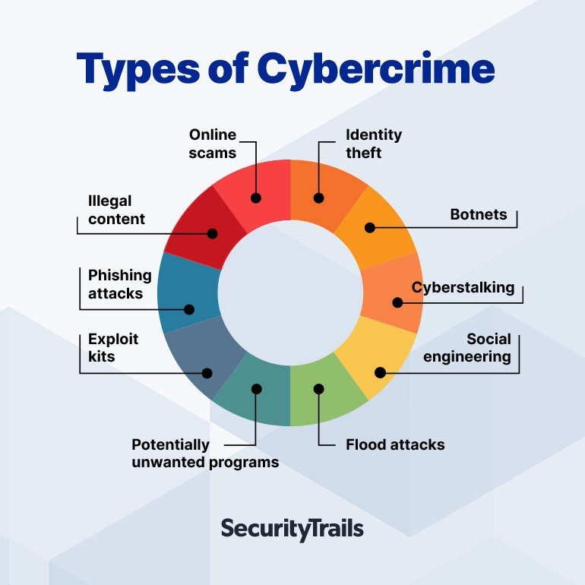

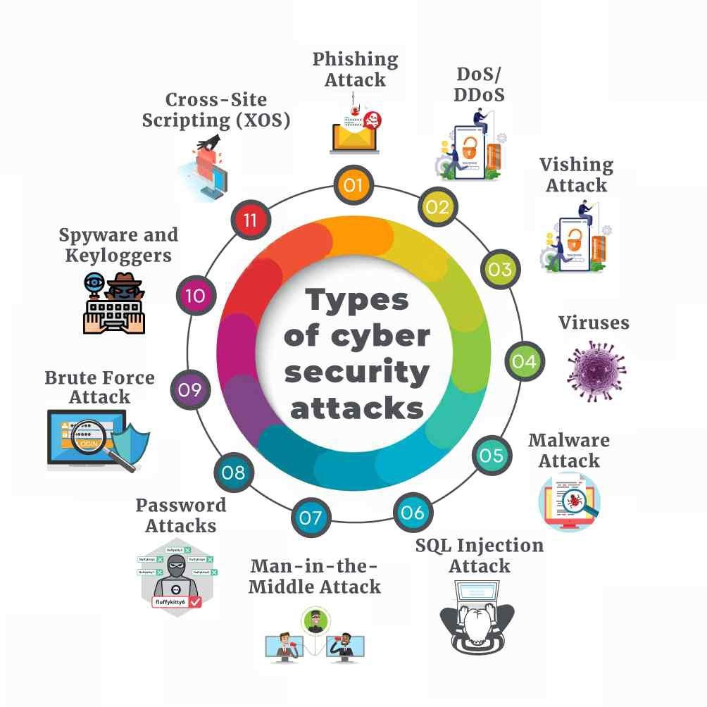

* **Phishing:** Fraudulent attempts to obtain sensitive information (e.g., passwords, creditcard numbers) by masquerading as a trustworthy entity.
* **Malware:** Software designed to disrupt, damage, or gain unauthorized access tocomputer systems.
* **Distributed Denial of Service (DDoS):** Flooding a network or server with traffic tooverwhelm it and prevent legitimate users from accessing services.
* **Identity Theft:** Stealing personal information to impersonate someone else forfinancial gain.
* **Ransomware:** Malware that encrypts files on a victim's computer and demandspayment to decrypt them.

**CIA Triad:** The CIA Triad is a widely accepted model for guiding policies forinformation security within an organization:

* **Confidentiality:** Ensuring that data is accessible only to authorized individuals orsystems.
* **Integrity:** Maintaining the accuracy and trustworthiness of data and systems.
* **Availability:** Ensuring that data and systems are accessible and usable byauthorized users when needed.

**AAA Framework**: The AAA framework stands for Authentication, Authorization, and Accounting:

* **Authentication:** Verifying the identity of users or systems attempting to accessresources.
* **Authorization:** Granting or denying access to resources based on the authenticatedidentity and the permissions associated with that identity.
* **Accounting:** Tracking the activities of authenticated users, including resourceusage, to ensure accountability and facilitate auditing.

**OWASP (Open Web Application Security Project):** OWASP is a non-profit organization focused on improving software security. It provides freely available resources,tools, and documentation to help organizations and developers improve the security of web applications. OWASP's flagship document is the OWASP Top Ten, which lists the ten mostcritical security risks to web applications.

**SQL Injection:** SQL Injection is a type of cyber-attack where malicious SQL code isinserted into an entry field for execution. It can be used to manipulate a database or gainunauthorized access to data, often by exploiting vulnerabilities in web applications that interact with databases.

**Cross Site Scripting (XSS):** XSS is a security vulnerability commonly found in webapplications. It allows attackers to inject malicious scripts into web pages viewed by otherusers. These scripts can then execute in the browsers of unsuspecting users, potentially compromising their sessions, stealing cookies, or performing other malicious actions.

**Firewall:** A firewall is a network security device or software that monitors and controlsincoming and outgoing network traffic based on predetermined security rules. It acts as abarrier between a trusted internal network and untrusted external networks (such as the internet), allowing or blocking traffic based on defined security policies.

**Vulnerability Scanner - Acunetix:** Acunetix is a popular web vulnerability scanner used by security professionals and organizations to proactively identify security weaknesses in web applications. It scans websites and web applications for vulnerabilities such as SQL Injection, XSS, CSRF (Cross-Site Request Forgery), and other security issues that could be exploited by attackers. Acunetix provides detailed reports and recommendations to help organizations mitigate these vulnerabilities and improve their overall security posture.

# Skills Acquired:

##### Computer Vision:

* Techniques and applications for enabling machines to interpret and process visualinformation.
* Understanding of image processing techniques.
* Development and implementation of vision-based solutions.

##### Convolutional Neural Networks (CNN):

* + Proficiency in building and training CNN models.
  + Knowledge of CNN architecture and applications in image recognition and classificationtasks.

##### Image Classification:

* + Experience using Google Teachable Machine for image classification.
  + Understanding the workflow from image collection to model training and evaluation.
  + Skills in categorizing and labeling images based on specific rules.

##### Image Object Detection:

* + Ability to develop object detection models.
  + Knowledge of algorithms such as YOLO, SSD, and Faster R-CNN.
  + Practical applications of object detection in various domains.

##### Medical Image Analysis and Labelling:

* + Skills in using Roboflow for image labeling.
  + Understanding the importance of accurate labeling in medical image analysis.
  + Proficiency in developing AI models for medical applications.

##### Human Pose Estimation:

* Experience using Google Teachable Machine for human pose estimation.
* Understanding techniques for detecting and tracking human figures and their poses inimages or videos.

##### Chatbot Development:

* + Skills in creating interactive agents that can converse with humans using naturallanguage.
  + Experience with designing and integrating conversational user interfaces.

##### Google Dialogflow:

* Proficiency in using Google Dialogflow for natural language understanding.
* Skills in developing and deploying conversational agents.

##### Generative AI:

* Techniques for generating new content such as music, text, and images.
* Experience with models for music generation, text generation, and image generation.

##### AI Models:

* + Knowledge of various AI models used for different applications.
  + Skills in summarization, fill-mask models, and transformers.

##### Visual Question & Answering:

* + Development of models that answer questions about images.
  + Integration of visual and textual data for question answering.

##### Table Question & Answering:

* + Proficiency in creating models that answer questions using tabular data.
  + Proficiency in creating models that answer questions using tabular data.

##### Large Language Models (LLMs):

* + Knowledge of advanced language models like Claude, GPT, Gemini, LLaMA3, andOpen LLMs.
  + Experience in text generation and language understanding.

##### Other Topics:

* + Implementation of Google's Vision API for image analysis.
  + Understanding and using small language models (SLMs) like BERT and GPT.
  + Skills in deploying and managing AI models using Ultralytics Hub.
  + Development of lightweight models for mobile and embedded devices using TensorFlow

# Cyber Security Skills Acquired:

##### Cyber Security Basics:

- Fundamental principles and practices for protecting computer systems and networks from cyber threats.

##### Types of Cyber Crimes:

* + Understanding various forms of illegal activities conducted via the internet.

##### CIA Triad:

* + Core principles of cybersecurity—Confidentiality, Integrity, and Availability**.**

##### AAA Framework:

* + Knowledge of Authentication, Authorization, and Accounting framework for managingand securing identities and their access.

##### OWASP:

* + Familiarity with the Open Web Application Security Project and its focus on improving software security.

##### SQL Injection:

* + Understanding of SQL injection techniques and prevention methods.

##### Cross Site Scripting (XSS):

* + Skills in identifying and mitigating XSS vulnerabilities.

##### Firewall:

* + Knowledge of network security systems that monitor and control incoming and outgoing network traffic based on predetermined security rules.

##### Vulnerability Scanner:

* + Proficiency in using tools like Acunetix for identifying and addressing vulnerabilities in systems and applications.

# Conclusion:

#### Internship Experience at AIMERS

I am grateful to AIMERS (Artificial Intelligence Medical and Engineering Researchers Society) for an enriching internship experience. Throughout this journey, I have gained invaluable knowledge and skills in AI and engineering. Special thanks to Sai Satish Sir for his guidance and support. This experience has significantly contributed to my professional growth, and I look forward to applying these learnings in my future endeavors.

#### Valuable Learning Opportunities at AIMERS

During my internship at AIMERS, I had the opportunity to work on cutting-edge projects and collaborate with experienced professionals in the field of artificial intelligence. The hands-on experience and mentorship provided have deepened my understanding of AI applications and methodologies. I am particularly thankful for the supportive environment and the emphasis on practicallearning, which has prepared me well for future challenges in the tech industry.

# References and Acknowledgements:

##### References:

1.ChatGPT-4o 2.Google 3.Youtube 4.Hugging Face

##### Acknowledgments:

CSE Department HOD: Dr.B.SUJATHA MAM

**Thanking you Mam for conducting the internships which are useful for our future.**

Organization: AIMERS Society Sai Satish sir

Thank You Sir for providing this type of internship. Thanking you sir for sharing your timeand experience with us.

**Heartly Thanks to Sai Satish Sir.**

G.TEJASRI

**22551A0592**

### Godavari Institute of Engineering & Technology(GIET)

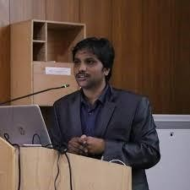

SAI SATISH (INDIAN SERVERS CEO)

**Heartly Thanks to Dr.B.Sujatha Mam**

Dr.B.SUJATHA Mam(CSE HOD)

